Commission on the status of women
Harassment targeted towards women through social media
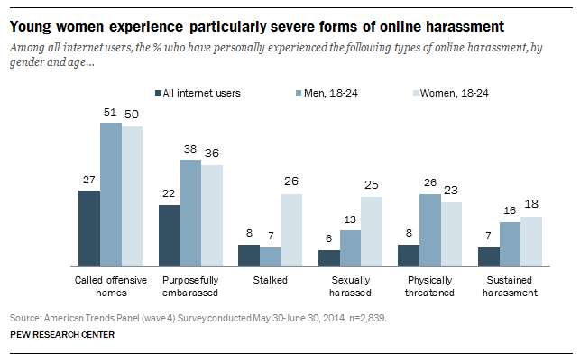
The globalised world that we currently find ourselves in brings many threats. The internet is genial soil for many of these, and harassment targeted towards women is no exception. They become victims of online-embarrassment, physical threats, sexual harassment and/ or stalking. These are the more severe instances but all should be considered being serious. The UN needs to act upon this issue.

Surveys estimated that about 40% of all Internet users have been exposed to online harassment. Furthermore, respectively 18% and 25% of women between the ages of 18-24 have experienced sexually harassment as well as sustained harassment, whereas it for the men of the same age is respectively 13% and 16%. The states that are to debate this issue shall of course focus on researching the status of the issue in their respective case. This implies seeking statistics, reading relevant proposals on solutions on the topic and research and clarify the history of the issue – for your own as well as the debate’s sake. Advantageously, when done with aforementioned, you can with make drafts of solutions on the topic.

Harassment as defined by law
The act of systematic and/or continued unwanted and annoying actions of one party or a group, including threats and demands.
The purposes may vary, including racial prejudice, personal malice, an attempt to force someone to quit a job or grant sexual favors, apply illegal pressure to collect a bill, or merely gain sadistic pleasure from making someone fearful or anxious.

Further reading
http://journalistsresource.org/studies/society/gender-society/internet-harassment-online-threats-targeting-women-research-review
http://www.newrepublic.com/article/119973/pew-survey-women-harassed-more-social-media
http://www.theatlantic.com/technology/archive/2014/10/the-unsafety-net-how-social-media-turned-against-women/381261/
http://www.pewinternet.org/2014/10/22/online-harassment/

http://www.pewinternet.org/files/2014/10/PI_OnlineHarassment_102214_pdf1.pdf

