Securing the rights of women during the conflict in Syria and bordering countries
Commission on the status of women
Susanne Simona Seested

Introduction to the issue:
With nearly half of Syria’s population displaced or made refugees by the conflict, the head of a United Nations-mandated human rights inquiry has warned that while the world silently watches, Syrians of all backgrounds are being subjected to war crimes as well as other gross violations of their human rights. According to a statement made by the Independent International Commission of Inquiry on the Syrian Arab Republic on the 3rd of September 2015, the armed conflict in Syria has become a lengthy and chaotic non-international armed conflict. An escalating number of battling parties continue to display a complete disregard for their international legal obligations by targeting civilians, residential areas, and locations preserved under international law. Furthermore Paulo Sérgio Pinheiro, Chair of the Independent International Commission of Inquiry on the Syrian Arab Republic, ascertains that without stronger efforts to bring parties to the peace table, ready to compromise, current trends suggest that the Syrian conflict will carry on for the foreseeable future.
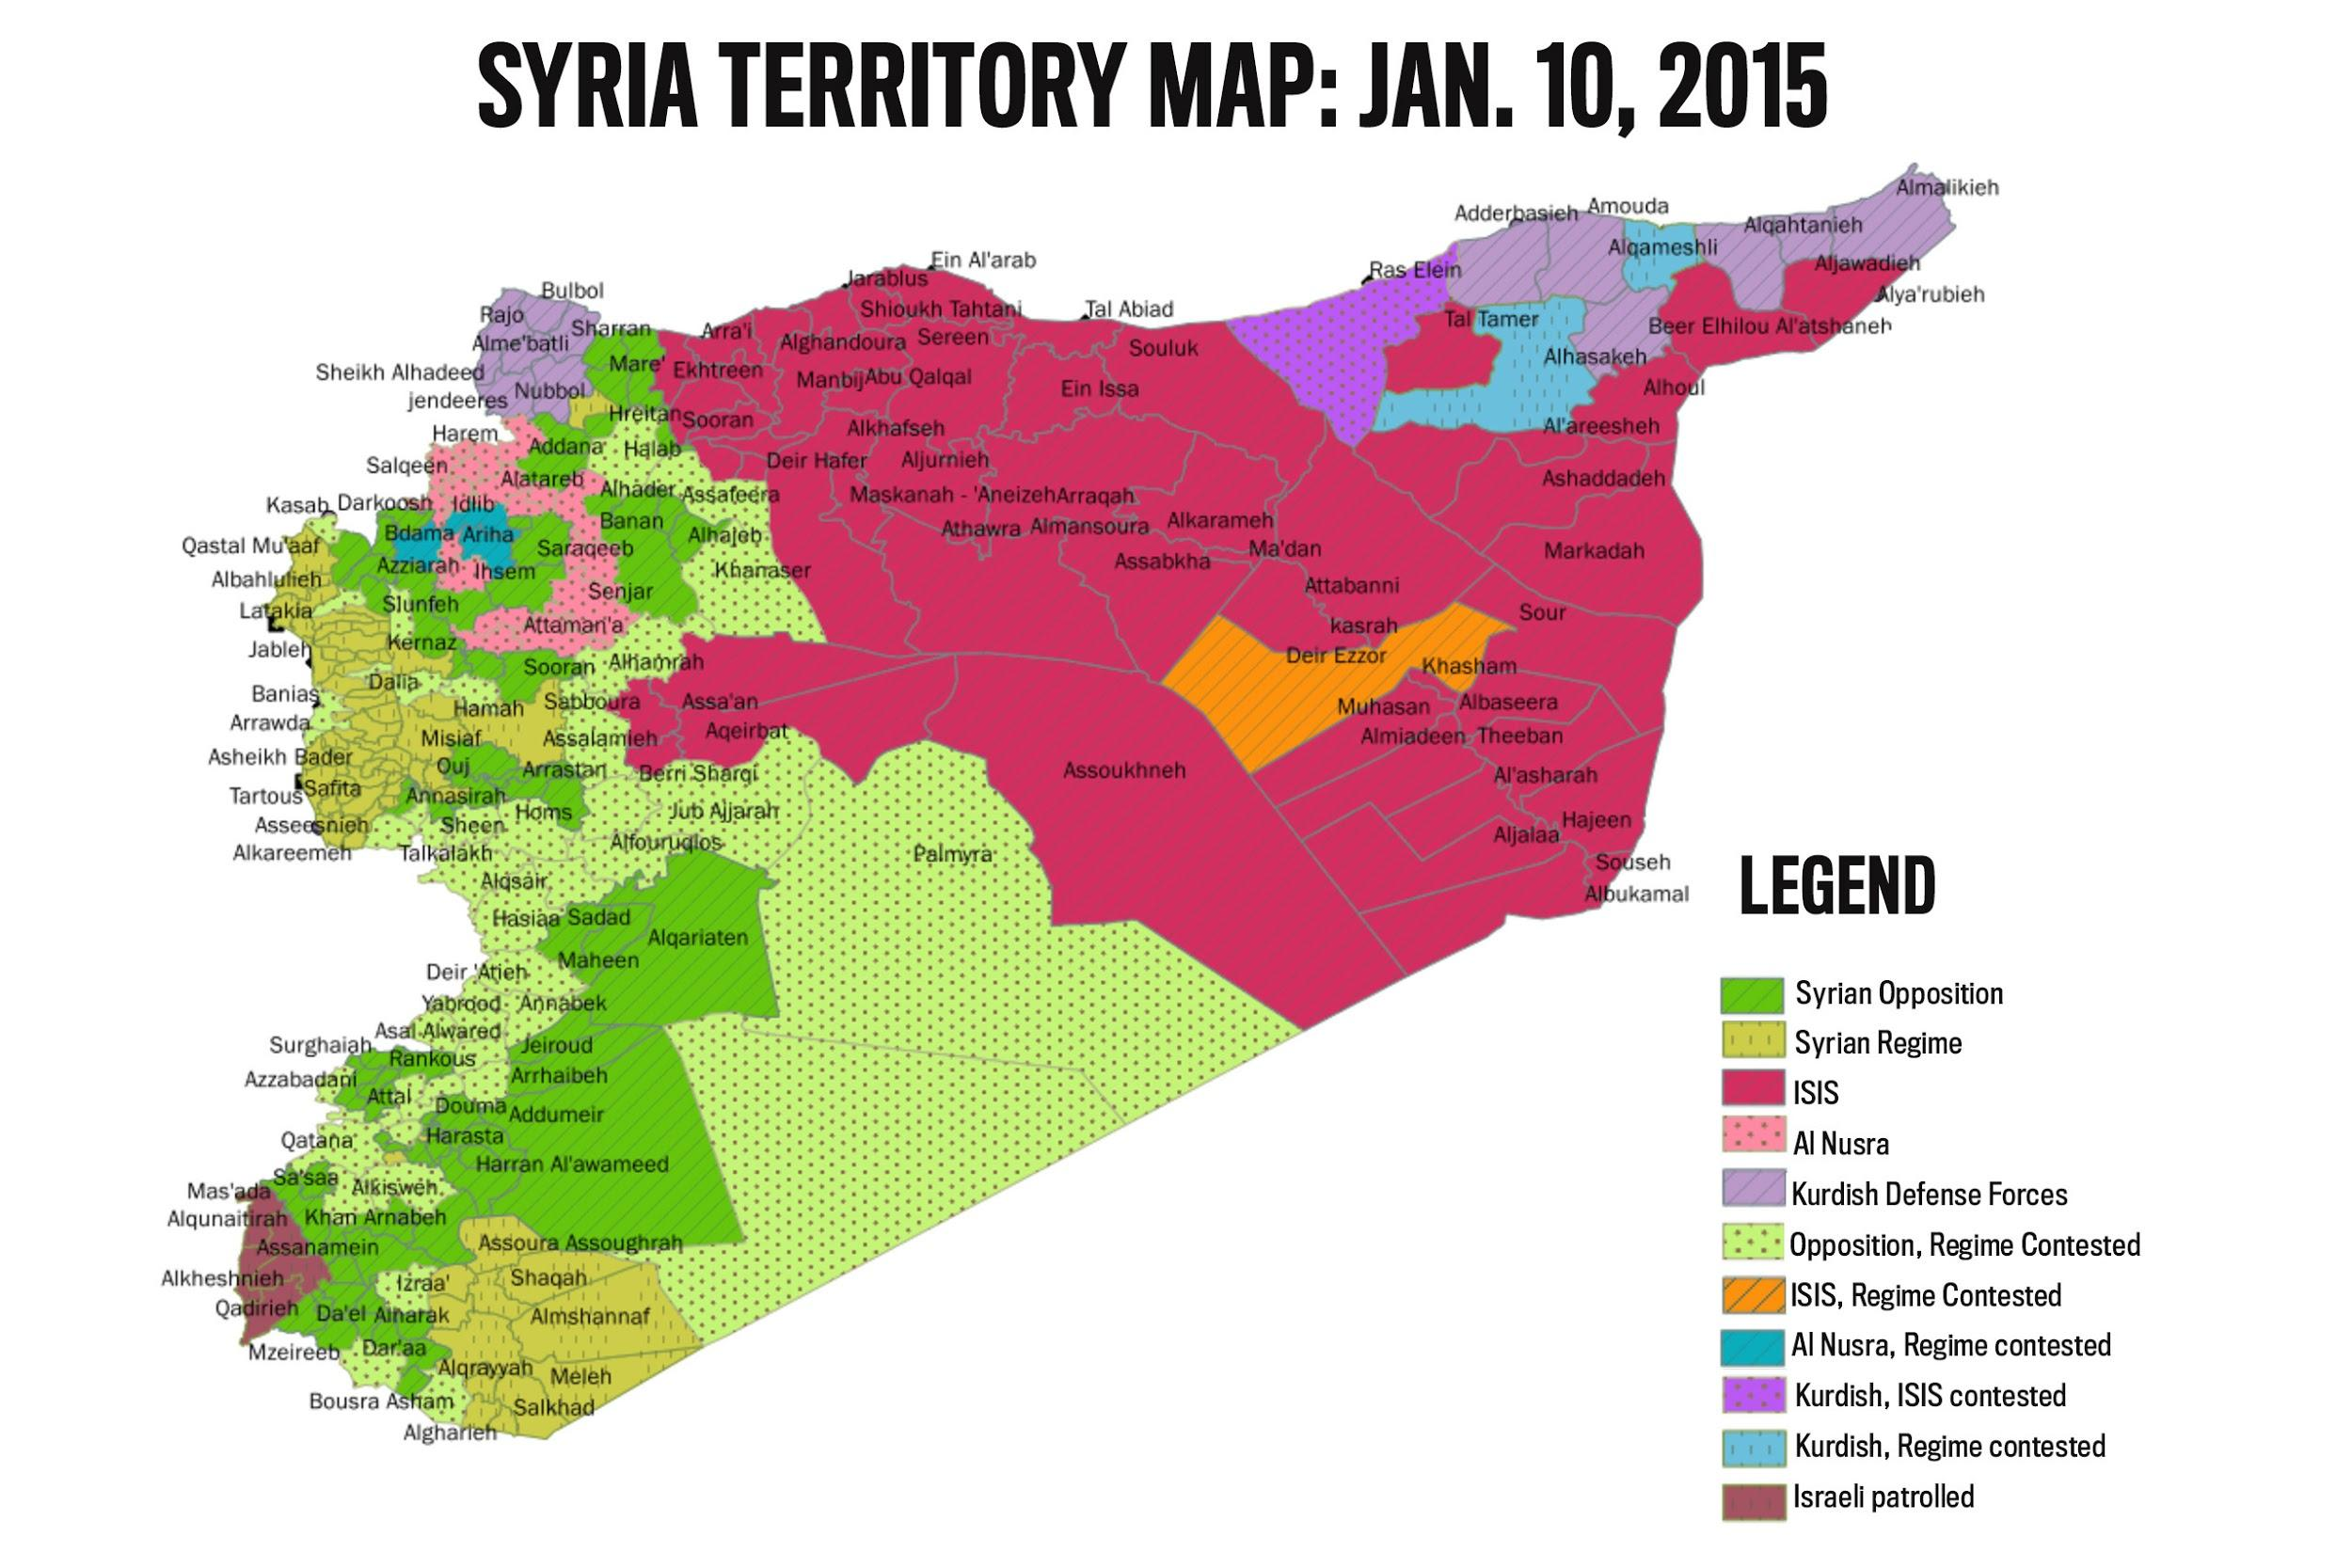

Background information
The report published on the 3rd of September 2015 by the Independent International Commission of Inquiry on the Syrian Arab Republic further notes that Human rights violations are being carried out by both Government and terrorist organisations, such as but not limited to the Islamic State of Iraq and the Levant and Jabhat Al-Nusra. Government forces have been observed to have committed gross violations against human rights and war crimes of murder, torture, rape, sexual violence and targeting unarmed civilians. Women are especially targeted with Government forces arresting female lawyers, journalists and peace activists. Meanwhile ISIL continues to murder, torture, rape, and forcibly displace civilians including women and children. Additionally ISIL have placed women and girls entirely under the control of male relatives. Furthermore ISIL violate women and girls over the age of 10 rights by not letting them leave their homes without a close male relative. After capturing cities in Iraq, ISIL issued guidelines on how to wear clothes and veils. ISIL warned women in the city of Mosul to wear full-face veils or face severe punishment.

Since the conflict began, there have been many reports of sexual abuse and enslavement in ISIL-controlled areas of women and girls, predominantly from the minority Christian and Yazidi communities. Fighters are told that they are free to have sex with or rape non-Muslim captive women. Haleh Esfandiari from the Woodrow Wilson International Center for Scholars has highlighted the abuse of local women by ISIL militants after they have captured an area. "They usually take the older women to a makeshift slave market and try to sell them. The younger girls … are raped or married off to fighters", she said. As of August 2015, it seems the trade in sex slaves appeared to remain restricted to Yazidi women and girls. Nazand Begikhani said of the Yazidi victims, "These women have been treated like cattle … They have been subjected to physical and sexual violence, including systematic rape and sex slavery. They've been exposed in markets in Mosul and in Raqqa, Syria, carrying price tags.". This was confirmed by a United Nations report issued on 2nd October 2014. The report was based on 500 interviews with witnesses, and said that ISIL took between 450 to 500 women and girls to Iraq's Nineveh region in August, where 150 unmarried girls and women were transported to Syria with the intention to either be given to ISIL fighters as a reward or to be sold as sex slaves.

Actions taken by the UN:
1975: The first world conference on women was held in Mexico city.
1995: The Fourth World Conference on Women was held in Beijing and marked a significant turning point for the global agenda for gender equality. The Beijing Declaration and the Platform for Action, adopted unanimously by 189 countries, is an agenda for women’s empowerment and considered the key global policy document on gender equality.
4th October 2011: China and Russia veto a UN resolution condemning the government crackdown on protests.
22nd August 2011: The Independent International Commission of Inquiry on the Syrian Arab Republic was established with a mandate to investigate all alleged violations of international human rights law since March 2011 in the Syrian Arab Republic.
22nd January 2014: Talks begin in Geneva between Syrian government and opposition delegates at the behest of US and Russia, but end without a breakthrough.
22nd February 2014: Resolution 2139 was passed unanimously by the SC. The resolution calls on all parties in the Syrian Civil War to permit free access to humanitarian aid
22nd May 2014: Russia-China veto a UN resolution to refer Syria to the International Criminal Court.
14th July 2014: Resolution 2165 was passed unanimously by the SC concerning the Syrian civil war, Humanitarian situation in Syria and the establishment of a monitoring mechanism.

Definitions of organisations and key terms:
ISIL:
The Islamic State of Iraq and the Levant (ISIL), also known as the Islamic State of Iraq and Syria (ISIS) or the Islamic State of Iraq and ash-Sham, or Islamic State (IS), is a Salafi jihadist extremist militant group. The organisation is led by Sunni Arabs from Iraq and Syria. As of March 2015, it has control over territory occupied by more than ten million people in Iraq and Syria. Furthermore ISIL has control over small areas in Libya, Nigeria and in the Nangarhar Province in eastern Afghanistan. The organisation also operates or has affiliates in other parts of the world, including South Asia.

International Commission of Inquiry on the Syrian Arab Republic:
The Independent International Commission of Inquiry on the Syrian Arab Republic was established on 22 August 2011 by the Human Rights Council with a mandate to investigate all alleged violations against human rights since March 2011 in the Syrian Arab Republic.

General Union of Syrian Women:
General Union of Syrian Women (GUSW) is the most influential women's rights organisation in Syria. GUSW was founded in 1967, as a merger between different pre-existing women's rights groups.

Jabhat Al-Nusra:
The al-Nusra Front, or Jabhat al-Nusra (JN or JaN), occansionally called al-Qaeda in Syria or al-Qaeda in the Levant, is a Sunni Islamic jihadist organisation fighting against Syrian Government forces in the Syrian Civil War, with the aim of establishing an Islamist state in the country.

Timeline:
1949: Women in Syria received the right to vote.
1963: Ba'th Party took power in Syria, and pledged full equality between women and men as well as full workforce participation for women.
1967: Syrian women formed a quasi-governmental organization called the General Union of Syrian Women (GUSW), a coalition of women's welfare societies, educational associations, and voluntary councils intended to achieve equal opportunity for women in Syria.
April 7th, 2006: GUSW released a report, developed in cooperation with the United Nations Development Programme, on domestic violence against women in Syria. The report was seen as ground-breaking, as domestic violence is often seen as an intra-family affair in the country.
March 15th 2011: The Syrian civil war begins.

Things to consider:
- What position would my country take on this topic?
- To what extent is my nation involved in this issue?
- Is my nation’s citizens’ safety threatened?
- Has my nation contributed to any of the actions taken by the UN?
- What potential solutions would my nation support?
  - (Consider social, economic, etc. consequences)

Read more:
http://www.un.org/apps/news/story.asp?NewsID=51788#.VhD-gNZx0hY

http://www.ohchr.org/EN/HRBodies/HRC/IICISyria/Pages/AboutCoI.aspx

http://www.ohchr.org/EN/HRBodies/HRC/RegularSessions/Session30/Pages/ListReports.aspx

http://www.ohchr.org/Documents/HRBodies/HRCouncil/CoISyria/ResS17_1.pdf

http://www.un.org/en/ga/search/view_doc.asp?symbol=S/RES/2165(2014)

https://www.hrw.org/news/2014/07/02/syria-wars-toll-women

http://www.unwomen.org/en/how-we-work/intergovernmental-support/world-conferences-on-women#sthash.jIAJtbDa.dpuf

http://laurenmwolfe.com/women-under-siege/

http://www.middleeasteye.net/news/timeline-key-dates-syrias-civil-war-1107866780

