Commission on the status of women
The security surrounding female politicians and activists
There is a long history of protest against gender-based violence within the political spheres. The fourth world conference on women in Beijing in 1995 was a huge step in the way of achieving greater equality and opportunity for women. Unfortunately the road is long and we have since the conference seen a tightening of violence against women globally.
The goal is to achieve a gender balance in political representation and decision-making. This can only be accomplished by ensuring women are not opposed to discriminating or violent behaviour. In-Depth interviews ascertain that female politicians and activists face a much tougher challenge than men. Traditions are the enemy of the female politician and activist. In Muslim countries women are kept from expressing their political opinion due to the social role they have been given. It is evident that poor women, those from lower castes and those new to politics are most at risk of violence. Young women who were in their twenties and those who are not from a political family also face a higher risk of being targeted by violence.
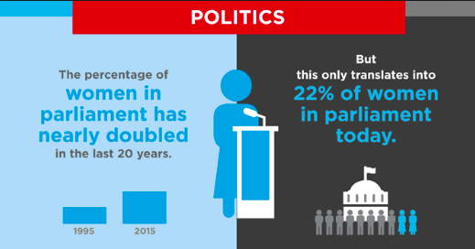
The greatest form of violence ad mentioned by women was their socie-psycological conditioning where they would not dare to oppose their husband/father/Khap Panchayat on issues related to women. If they did they would not win. The real change would be when women cross this psychological barrier and start demanding their rightful position in the society and politics of their country. Violence against female politicians and activists is a problem we desperately need to address and act around.
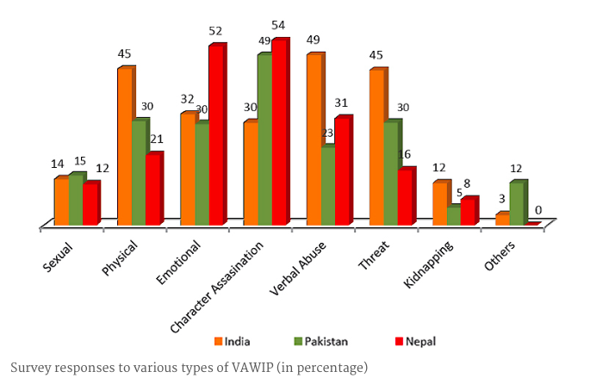
Further reading
http://www.unwomen.org/~/media/headquarters/attachments/sections/library/publications/2014/violence%20against%20women%20in%20politics-report.pdf
http://www.europarl.europa.eu/sides/getDoc.do?type=COMPARL&reference=PE-551.923&format=PDF&language=DA&secondRef=01
http://www.peacewomen.org/e-news/anniversaries-womens-activism
https://www.ndi.org/gender-women-democracy

