The question of income inequality curbing global prosperity.

Economic and Financial Committee

Main Chair: Flaminia Ruiz
Deputy Chair: Simon Barnwell

What is income inequality?

Income inequality, also known as economic inequality, refers to how economic factors are distributed amongst individuals in a group, amongst societies in a population, or amongst countries. Economists generally think of three factors of economic difference: wealth (wealth inequality), income (income inequality), and consumption. The issue of economic inequality can implicate notions of equity, equality of outcome, and equality of opportunity. Some studies have emphasized inequality as a growing social problem. Too much inequality can be destructive, and might curb global prosperity. Early statistical studies comparing inequality to economic growth had been inconclusive, however in 2011, International Monetary Fund economists showed that greater income equality increased the duration of countries' economic growth spells more than free trade, low government corruption, foreign investment, or low foreign debt. Economic inequality varies between societies, historical periods, economic structures and systems. The term can refer to cross sectional distribution of income or wealth at any particular period, or to the lifetime income and wealth over longer periods of time. There are various ways for measuring economic inequality. A widely used one is the Gini coefficient.

Global overlook of economic inequality:
Using the Gini coefficient, the income inequality has been measured across the world.

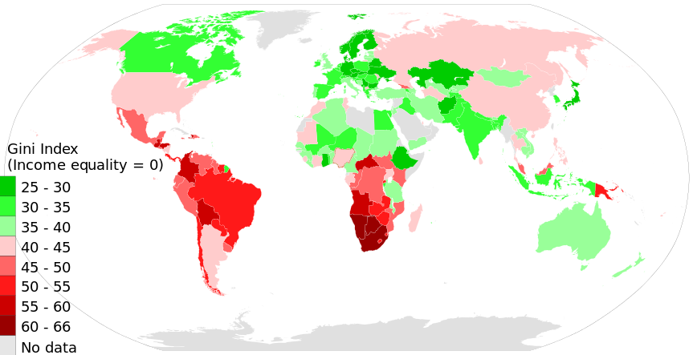

As seen on the illustration, the income inequality of different countries varies, though some places have higher inequality than others. Australia, Canada, Europe, parts of South Asia and parts of North Africa all have relatively low inequality income-wise. However, the South African and South American regions have a rather high inequality, whereas American, Argentina and the majority of Asia have medium economic inequality.

What causes income inequality?

There are multiple reasons for income inequality within societies, however some of the common factors which have thought to impact this are:
- Gender discrimination
- Ethnic discrimination
- Computerization/automation
- Policy reforms
- Regressive taxation
- Globalization

Curbing global prosperity:

Today’s income inequality is the measure to be the highest in decades, and according to previous IMF studies, income inequality (measured by the Gini coefficient) negatively affects growth and its sustainability. This analysis is build by examining how individuals’ income shares, at various points in the distribution, a matter for growth and prosperity. The IMF also states that the increasing level of income inequality may result in lower social mobility and a limitation of opportunities:
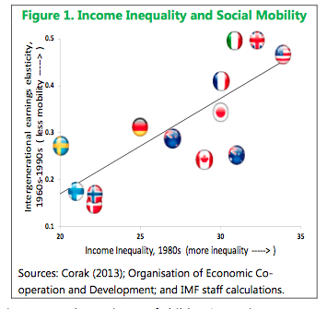

Further reading:
- https://www.imf.org/external/pubs/ft/sdn/2015/sdn1513.pdf

- http://www.economist.com

- http://www.un.org/esa/socdev/documents/reports/InequalityMatters.pdf

- https://www.cia.gov/library/publications/the-world-factbook/fields/2172.html

