GA-3 Social, Cultural and Humanitarian Committee (SOCHUM)

Taking an international stand against antisemitism
Antisemitism is prejudice against, hatred of, or discrimination against Jews as an ethnic, religious, or racial group. A person who holds such positions is called an anti-Semite. Antisemitism is widely considered to be a form of racism.
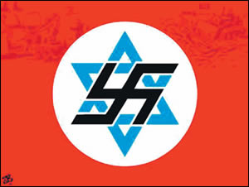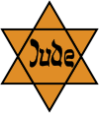
Antisemitism may be manifested in many ways, ranging from expressions of hatred or discrimination against individual Jews to organized violent attacks by mobs, state police, or even military attacks on entire Jewish communities. Although the term did not come into common usage until the 19th century, it is now also applied to historic anti-Jewish incidents. Notable instances of persecution include the pogroms which preceded the First Crusade in 1096, the expulsion from England in 1290, the massacres of Spanish Jews in 1391, the persecutions of the Spanish Inquisition, the expulsion from Spain in 1492, Cossack massacres in Ukraine of 1648–1657, various pogroms in Imperial Russia between 1821 and 1906, the 1894–1906 Dreyfus affair in France, the Holocaust in German-occupied Europe, official Soviet anti-Jewish policies and Arab and Muslim involvement in the Jewish exodus from Arab and Muslim countries.

Antisemitism is manifested in many forms. According to Louis Harap it is manifested in six forms:
- religious (Jew as Christ-killer),
- economic (Jew as banker, usurer, money-obsessed),
- social (Jew as social inferior, "pushy," vulgar, therefore excluded from personal contact),
- racist (Jews as an inferior "race"),
- ideological (Jews regarded as subversive or revolutionary),
- cultural (Jews regarded as undermining the moral and structural fiber of civilization).
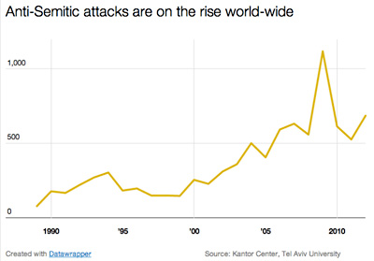

Antisemitism is an increasingly rising problem and many Jewish people are assaulted, harmed and killed in several anti-Semitic incidents. These incidents are happening in different public areas such as college campuses or synagogues. Jewish people are discriminated because of their religion, beliefs and several other reasons. According to The Universal Declaration of Human Rights “Everyone has the right to life, liberty and security of person.” (Article 3) and “Everyone has the right to freedom of thought, conscience and religion; this right includes freedom to change his religion or belief, and freedom, either alone or in community with others and in public or private, to manifest his religion or belief in teaching, practice, worship and observance.” (Article 18). Because of these incidents many Jewish people disenfranchised their rights mentioned in The Universal Declaration of Human Rights.

As the Social, Cultural and Humanitarian Committee we should create a resolution that will prevent the discrimination against Jewish society and ensure the rights of Jewish people.

Questions to answer
- How can UN prevent the discrimination against Jewish Society?
- How can UN prevent anti-Semitic incidents?
- How can UN raise awareness about antisemitism and anti-Semitic incidents?
- How can non-governmental organizations take part in this issue?

Bibliography: https://en.wikipedia.org/wiki/Antisemitism
http://www.motherjones.com/kevin-drum/2015/02?page=5
http://archive.adl.org/main_arab_world/asam_july_dec_intro_2005.html#.ViStJfnhChc

Further Reading
- http://archive.adl.org/anti_semitism/new_threat/90ways.pdf
- https://en.wikipedia.org/wiki/Antisemitism
- http://stopantisemitismtoday.weebly.com/links.html
- http://www.adl.org/assets/pdf/anti-semitism/united-states/audit-2014-inforgraphics.pdf
- http://antisemitism.org.il/?lang=en

