Financing the JI and IPCC and the possibility of financing it through emissions trading

Introduction

Today many agree that climate change is a major problem. Many believe that climate change may be one of the biggest threats towards our planet. Recent years research show that the temperature is increasing in various regions, extreme weather patterns occur and rising sea levels. The climate change is expected to hit developing countries the hardest, since they do not have sufficient money to protect themselves. The climate change is a result of the greenhouse effect. The greenhouse effect is when gases are released into the air, where they absorb the energy that is trying to leave the earth’s atmosphere to maintain a balance in energy. However, since the energy cannot leave it results in an increase in temperature on the earth, which will increase sea levels and the change of extreme weather conditions. Greenhouse gasses are carbon dioxide, methane, nitrous oxide and fluorinated gasses. Some countries such as but not limited to the United States of America and larger corporations denied and opposed all about the climate change because they were afraid of a negative profit impact, if they had to make major changes to how they do business. However, some say that the climate change is not cause by humans. They even state that the carbon dioxide is good for plants, which it actually is, and that climate change is only regional and not global. Furthermore, an UN expert reviewer for the Intergovernmental Panel on Climate (IPCC), Anthony R. Lupo, says that the earth will adopt to the changes as it always has.

Definition of Key Terms

Intergovernmental Panel on Climate Change (IPCC)
The IPCC is assessing research regarding climate change. It was created in 1988 by the United Nations Environment Programme (UNEP) and World Meteorological Organization (WMO) to provide the world with clear scientific knowledge regarding the climate change and what could happen in the future if we did nothing. Today the IPCC delivers regular a report regarding the situation on climate change.

Joint Implementation (JI)
Joint Implementation is one of three mechanisms in the Kyoto Protocol, which purpose are to reduce the greenhouse gases emission into the atmosphere through national measure. The JI mechanism is when a country invests in an emission reduction project in another country instead of reducing emission domestically. By doing this the country that is investing gets an emission reduction unit (ERU), which helps the country towards their emission reduction target. The investments are called Joint Implementation Projects.

United Nations Framework Convention on Climate Change (UNFCCC)
The major objective of the convention, UNFCCC, is to stabilize the greenhouse gas concentration in the atmosphere, so that it will prevent dangerous interference with the climate system. The UNFCCC was ratified by 196 countries in 1992.

United Nations Environment Programme (UNEP)
The UNEP is the leading global environmental authority, which sets the global environment agenda. Furthermore, it seeks to strength the ability of countries to integrate climate change responses into their national development processes, especially developing countries.

Kyoto Protocol
Kyoto Protocol is an extension to the UNFCCC from 1992, which commits countries to reduce the greenhouse gas emission. It was ratified by 192 countries in 1997. Canada withdrew from the protocol in 2012. The Kyoto Protocol seeks to reduce the greenhouse gas emission by different measures. Furthermore, it offers countries three different mechanisms: International Emissions Trading, Clean Development Mechanism (CDM) and Joint implementation (JI).

History

In 1988 the United Nations Environment Programme (UNEP), the leading global environment authority, and World Meteorological Organization (WMO) created the Intergovernmental Panel on Climate Change (IPCC) to asses the scientific knowledge on the global warming and climate change. It was their job to provide the world with clear scientific knowledge regarding the climate change and what could happen if we nothing did.

In 1990 the first assessment report from UNEP was delivered. This report concluded that there was international agreement that the climate change was human-induced and that we needed to act quickly. This led to the United Nations Framework Convention on Climate Change (UNFCCC), which major objective was to stabilize the greenhouse gas concentration in the atmosphere, so that it will prevent dangerous interference with the climate system. It was ratified by 196 countries in 1992.

Country | Emission reduction (expressed in relation to total GHG emissions in the base year or period inscribed in Annex B to the Kyoto Protocol)
Bulgaria, Czech Republic, Estonia, Latvia, Liechtenstein, Lithuania, Monaco, Romania, Slovakia, Slovenia, Switzerland and EU* | -8%
US** | -7%
Canada***, Hungary, Japan and Poland | -6%
Croatia | -5%
New Zealand, Russian Federation and Ukraine | 0%
Norway | +1%
Australia | +8%
Iceland | +10%
* The 15 States who were EU members in 1997 when the Kyoto Protocol was adopted, took on that 8% target
** The US has indicated its intention not to ratify the Kyoto Protocol.
***On 15 December 2011, the Depositary received written notification of Canada's withdrawal from the Kyoto Protocol. This action became effective for Canada on 15 December 2012.
Source: http://unfccc.int/kyoto_protocol/items/3145.php

All countries that ratified the UNFCCC need to set a target for emission reduction, which they could work towards. Furthermore, the world was split up in categories. Annex I is classified as industrialized countries, economies in transition (EITs) and the European Union (EU). Annex II is made up of members of the Organization for Economic Cooperation and Development (OECD). The Annex II countries are required to assist and provide financial support to developing and EIT countries.

In 1995 the second assessment report from UNEP was delivered. This time the report provided important material regarding climate change. The world decided that we needed to take action. Therefore, they made an extension, the Kyoto Protocol in 1997, to the UNFCC from 1992. This protocol provided countries with three different mechanisms to reduce the emission of greenhouse gasses. The first mechanism is the International Emission Trading, which allowed countries to sell the emission they do not use. For example, states that exceeded their limits would have to buy it from countries who had clean energy and had more emission allowance than they needed. The second mechanism is Clean Development Mechanism (CDM). This mechanism would allow countries to invents in an emission reduction project in a developing country. The project will earn the investing country emission reduction credits (ERC). This mechanism stimulates sustainable development and emission reductions in developing countries, while giving industrialized countries some flexibility in how they meet their emission reduction targets. The third mechanism is the Joint Implementation (JI). This mechanism allows Annex B countries to invest in other Annex B countries with an emission reduction project. The investing country gains ERCs.
In 2005 the Kyoto Protocol enters force and the first commitment period starts in 2008 and is ending in 2012. During the years in the first commitment period countries needed to lower their emission to the target which they had selected. Some of the countries are represented in the table previously.

Key Issues

Financing the Joint Implementation (JI) and the Intergovernmental Panel on Climate Change (IPCC)

If we want to finance the JI and the IPCC, we need to make sure that countries does not move their companies to countries that has not ratified the Kyoto Protocol and the IPCC. In a result of companies moving their factories the overall emission in the atmosphere will not change, it might even change to the worse, because the company does not need to reduce its emission and might result in an increase instead. If a company should move, this will be a major economical issue in the companies’ home country. Furthermore, there will be a huge amount of jobs lost when the company moves, which will lead to unemployment in many countries under the emission reduction agreement.

Major Parties Involved
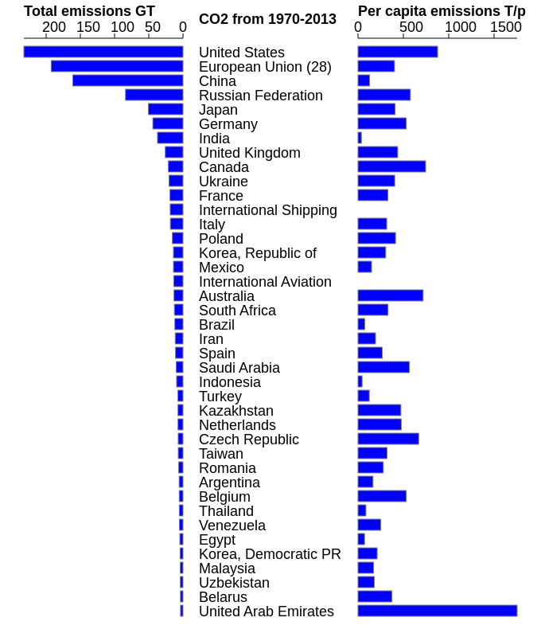
http://edgar.jrc.ec.europa.eu/overview.php?v=CO2ts_pc1990-2013

The United States of America
European Union
China
Russian Federation
Japan
Germany

In general countries that would have to pay a massive increase, if the money to financing the Joint Implementation (JI) and Intergovernmental Panel on Climate Change (IPCC) should regard nations with high emission.

Timeline

Year | Event
1979 | The worlds first climate change conference.
1988 | The UNEP and the WMO created IPCC to asses the scientific knowledge on the global warming and climate change.
1990 | IPCC’s first assessment report concludes that there was international agreement that the climate change was human-induced and that we needed to act before it is too late.
1991 | First meeting of the Intergovernmental Negotiating Committee takes place.
1992 | UNFCCC was ratified by 196 countries.
1994 | UNFCCC enters into force.
1995 | IPCC’s second assessment report provided important material regarding climate change.
1997 | Kyoto Protocol was adopted and ratified by 192.
2001 | IPCC’s third assessment report.
2005 | The Kyoto Protocol entered force.
2007 | IPCC’s fourth assessment report paid attention to the integration of climate change with sustainable development policies.
2008 | The first commitment period started.
2012 | The first commitment period ended.
2013 | The second commitment period starts.

Evaluation of Previous Attempts

Previous there has been no attempt beside the donations from Non-Governmental Organizations (NGOs) and countries.

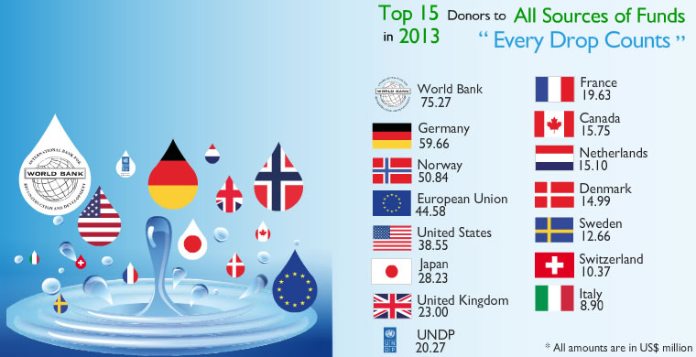
http://www.unep.org/about/funding/UNEPFunding2013Statistics/tabid/1060038/Default.aspx

Possible Solutions

The financing though emission trading system (ETS) could be a solution. However, in Europe the ETS is a major concern as their rivals in the United States of America (USA), China and India does not face the same pressure to reduce their CO₂ emission. Therefore, if the cost raises, due to the financing through emission trading to the Joint Implementation (JI) and Intergovernmental Panel on Climate Change (IPCC), there is a huge concern that companies will move their operations to ETS-free countries. This will then result in less jobs and economical issues in the companies’ home country.

Furthermore, financing JI and IPCC is complicated, because some countries are doing a lot to prevent emission. However, they might not be the richest country and can therefore not pay the most, even though they are using it more than the richest countries.

Another solution would be to put a tax on carbon and the other resources which are emitting emission. However, this will effect all countries, even though they do not want to donate towards climate change and will result in conflicts on how to sell the resources to countries.

Bibliography

IPCC (Intergovernmental Panel on Climate Change)
http://www.ipcc.ch

JI (Joint Implementation)
http://ji.unfccc.int/index.html

UNFCCC (United Nations Framework Convention on Climate Change)
http://unfccc.int/resource/docs/convkp/conveng.pdf

UNEP (United Nations Environment Programme)
http://www.unep.org/default.asp

WMO (World Meterological Organization)
https://www.wmo.int/pages/index_en.html

Kyoto Protocol
http://unfccc.int/resource/docs/convkp/kpeng.pdf

Emission Trade Explained
https://www.youtube.com/watch?v=ReOj12UAus4

Global Warming Natural, Not Man-Made
http://www.napsnet.com/pdf_archive/34/50144.pdf

Appendix

Examples of Joint Implementation
http://ji.unfccc.int/about/multimedia/ji_highlights.pdf

