1979: Apartheid in South Africa
HSC – Historic Security Council; Chiara Rocchetti

South Africa is a country blessed with an abundance of natural resources including fertile farmlands and unique mineral resources. South African mines are world leaders in the production of diamonds and gold as well as strategic metals such as platinum. The climate is mild, reportedly resembling the San Francisco bay area weather more than anywhere in the world.

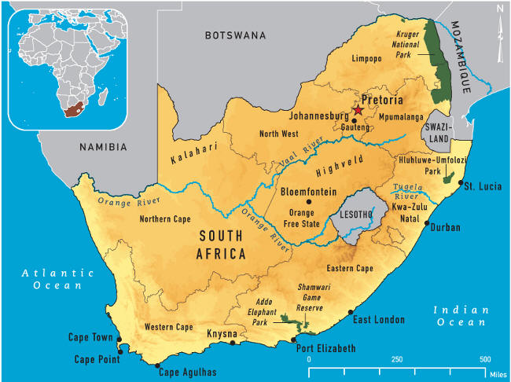

AN ANCIENT CUSTOM
South Africa was colonized by the English and Dutch in the seventeenth century. English domination of the Dutch descendents (known as Boers or Afrikaners) resulted in the Dutch establishing the new colonies of Orange Free State and Transvaal. Although the policy began officially in 1948, the practice of racial discrimination has deep roots in South African society. As early as 1788, Dutch colonizers began establishing laws and regulations that separated white settlers and native Africans. These laws and regulations continued after the British occupation in 1795, and soon led to the channeling of Africans into specific areas that would later constitute their so-called homelands. The discovery of diamonds in these lands around 1900 resulted in an English invasion which sparked the Boer War. In 1910 the separated Boer Republics united with the British Colonies became the Union of South Africa, while there were nearly 300 reserves for natives throughout the country. Following independence from England, an uneasy power-sharing between the two groups held sway until the 1940's, when the Afrikaner National Party was able to gain a strong majority. Strategists in the National Party invented apartheid as a means to cement their control over the economic and social system. Initially, aim of the apartheid was to maintain white domination while extending racial separation. Starting in the 60's, a plan of ``Grand Apartheid'' was executed, emphasizing territorial separation and police repression.
NINETEENTH CENTURY
From 1910 racial segregation and white supremacy had become central aspects of South African policy long before apartheid began. Apartheid is an Afrikaan term. The controversial 1913 Land Act, passed three years after South Africa gained its independence, marked the beginning of territorial segregation by forcing black Africans to live in reserves and making it illegal for them to work as sharecroppers. Opponents of the Land Act formed the South African National Native Congress, which would become the African National Congress (ANC).
The Great Depression and World War II brought increasing economic woes to South Africa, and convinced the government to strengthen its policies of racial segregation. In 1948, the Afrikaner National Party won the general election under the slogan “apartheid” (literally “separateness”). Their goal was not only to separate South Africa’s white minority from its non-white majority, but also to separate non-whites from each other, and to divide black South Africans along tribal lines in order to decrease their political power.
By 1950, the government had banned marriages between whites and people of other races, and prohibited sexual relations between black and white South Africans and the sanctioning of ``white-only'' jobs . In conjunction with the Reservation of Separate Amenities Act of 1953, even black workers who during the day worked in the now residentially white only cities were still required to use different public transportation, post offices, restaurants, schools, and even separate doors, benches, and counters. The Natives Urban Areas Act in 1952 and the Native Labor Act in 1953 placed more restrictions on the black majority in South Africa.
The Population Registration Act of 1950 provided the basic framework for apartheid by classifying all South Africans by race, including Bantu (black Africans), Coloured (mixed race) and white. A fourth category, Asian (meaning Indian and Pakistani) was later added. In some cases, the legislation split families; parents could be classified as white, while their children were classified as colored. Classification into these categories was based on appearance, social acceptance, and descent. For example, a white person was defined as ``in appearance obviously a white person or generally accepted as a white person.'' A person could not be considered white if one of his or her parents were non-white. The determination that a person was ``obviously white'' would take into account ``his habits, education, and speech and deportment and demeanor.'' A black person would be of or accepted as a member of an African tribe or race, and a colored person is one that is not black or white. The Department of Home Affairs (a government bureau) was responsible for the classification of the citizenry. Non-compliance with the race laws were dealt with harshly. All blacks were required to carry ``pass books'' containing fingerprints, photo and information on access to non-black areas.
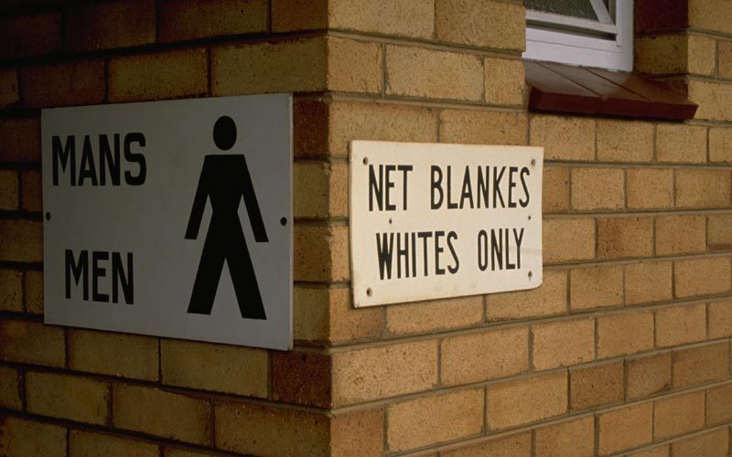
A series of Land Acts set aside more than 80 percent of the country’s land for the white minority, and “pass laws” required non-whites to carry documents authorizing their presence in restricted areas. In order to limit contact between the races, the government established separate public facilities for whites and non-whites, limited the activity of nonwhite labor unions and denied non-white participation in national government.
In 1953, the Public Safety Act and the Criminal Law Amendment Act were passed, which empowered the government to declare stringent states of emergency and increased penalties for protesting against or supporting the repeal of a law. In conjunction with the Reservation of Separate Amenities Act of 1953, even black workers who during the day worked in the now residentially white only cities were still required to use different public transportation, post offices, restaurants, schools, and even separate doors, benches, and counters. The Natives Urban Areas Act in 1952 and the Native Labor Act in 1953 placed more restrictions on the black majority in South Africa.
The penalties included fines, imprisonment and whippings. In 1960, a large group of blacks in Sharpeville refused to carry their passes; the government declared a state of emergency. The emergency lasted for 156 days, leaving 69 people dead and 187 people wounded. Wielding the Public Safety Act and the Criminal Law Amendment Act, the white regime had no intention of changing the unjust laws of apartheid.
Dr. Hendrik Verwoerd, who became prime minister in 1958, would refine apartheid policy further into a system he referred to as “separate development.” The Promotion of Bantu Self-Government Act of 1959 created 10 Bantu homelands known as Bantustans. Separating black South Africans from each other enabled the government to claim there was no black majority, and reduced the possibility that blacks would unify into one nationalist organization. Every black South African was designated as a citizen as one of the Bantustans, a system that supposedly gave them full political rights, but effectively removed them from the nation’s political body.
These homelands were independent states to which each African was assigned by the government according to the record of origin (which was frequently inaccurate). All political rights, including voting, held by an African were restricted to the designated homeland. The idea was that they would be citizens of the homeland, losing their citizenship in South Africa and any right of involvement with the South African Parliament which held complete hegemony over the homelands.
In one of the most devastating aspects of apartheid, the government forcibly removed black South Africans from rural areas designated as “white” to the homelands, and sold their land at low prices to white farmers. From 1961 to nowadays millions people were forcibly removed from their homes and deposited in the Bantustans, where they were plunged into poverty and hopelessness.
Accompanied by bloody repression of any movement of Blacks for Equality, she has reached such extremes of injustice and inhumanity to determine protests and resolutions condemning not only within the international forums of the African peoples, but also the UN and the Commonwealth, from which South Africa was ousted in 1961
Under apartheid, nonwhite South Africans (a majority of the population) would be forced to live in separate areas from whites and use separate public facilities, and contact between the two groups would be limited. Despite strong and consistent opposition to apartheid within and outside of South Africa, its laws remained till today.
Resistance to apartheid within South Africa took many forms over the years, from non-violent demonstrations, protests and strikes to political action and eventually to armed resistance. Together with the South Indian National Congress, the ANC organized a mass meeting in 1952, during which attendees burned their pass books. A group calling itself the Congress of the People adopted a Freedom Charter in 1955 asserting that “South Africa belongs to all who live in it, black or white.” The government broke up the meeting and arrested 150 people, charging them with high treason.
The Pan Africanist Congress (PAC) broke away from the ANC in 1958 and initiated its own campaign against apartheid. Both groups were eventually banned by the South African government and forced underground where they began violent campaigns of resistance. In the late 1960s, the South African Students’ Organization (SASO) was formed. Today it is known as the Black Consciousness Movement (BCM) in South Africa.

In 1960, at the black township of Sharpeville, the police opened fire on a group of unarmed blacks associated with the Pan-African Congress (PAC), an offshoot of the ANC. The group had arrived at the police station without passes, inviting arrest as an act of resistance. At least 67 blacks were killed and more than 180 wounded. Sharpeville convinced many anti-apartheid leaders that they could not achieve their objectives by peaceful means, and both the PAC and ANC established military wings, neither of which ever posed a serious military threat to the state. By 1961, most resistance leaders had been captured and sentenced to long prison terms or executed. Nelson Mandela, a founder of Umkhonto we Sizwe (“Spear of the Nation”), the military wing of the ANC, was incarcerated from 1963 to nowadays; his imprisonment would draw international attention and help garner support for the anti-apartheid cause.
In 1976, when thousands of black children in Soweto, a black township outside Johannesburg, demonstrated against the Afrikaans language requirement for black African students, the police opened fire with tear gas and bullets. The protests and government crackdowns that followed, combined with a national economic recession, drew more international attention to South Africa and shattered all illusions that apartheid had brought peace or prosperity to the nation. The United Nations General Assembly had denounced apartheid in 1973, and in 1976 the UN Security Council voted to impose a mandatory embargo on the sale of arms to South Africa.
The Pan Africanist Congress (PAC) broke away from the ANC in 1958 and initiated its own campaign against apartheid. Both groups were eventually banned by the South African government and forced underground where they began violent campaigns of resistance. In the late 1960s, the South African Students’ Organization (SASO) was formed. Today it is known as the Black Consciousness Movement (BCM) in South Africa.

To read more:
https://en.wikipedia.org/wiki/Apartheid
https://www.google.it/url?sa=t&rct=j&q=&esrc=s&source=web&cd=6&cad=rja&uact=8&ved=0CDcQFjAFahUKEwioodSFpcXIAhXF2xoKHfFxC1k&url=http%3A%2F%2Fwww.history.com%2Ftopics%2Fapartheid&usg=AFQjCNHLdDWfJoFgx1aiWHrZDdpkmAmo_g&sig2=EA6OK57RRRG59I1kD3BUKA
http://overcomingapartheid.msu.edu/listeducationalactivities.php
http://www.blackpast.org/gah/apartheid-1948-1994
http://www.bbc.co.uk/archive/apartheid/
http://search.un.org/?ie=utf8&output=xml_no_dtd&oe=utf8&Submit=Search&__utma=114554307.389033733.1442750035.1443709269.1444940120.3&__utmz=114554307.1444940120.3.3.utmcsr%3Dgoogle|utmccn%3D%28organic%29|utmcmd%3Dorganic|utmctr%3D%28not+provided%29&_ga=GA1.2.389033733.1442750035&__utmb=114554307.1.10.1444940120&__utmc=114554307&__utmt=1&_gat=1&NSC_j_xg-bqbdif_iuuq_mc_wt=ffffffff09f2003645525d5f4f58455e445a4a423660&query=apartheid+south+africa&tpl=un&lang=en&rows=10
https://www.cia.gov/search?q=apartheid+south+africa&site=CIA&output=xml_no_dtd&client=CIA&myAction=%2Fsearch&proxystylesheet=CIA&submitMethod=get

