1979: The Islamic Revolution in Iran
HSC – Historic Security Council; Chiara Rocchetti

WHAT ARE WE TALKING ABOUT?
When we talk about Islamic Revolution, we define a transformation of Iranian’s state and society, led by Shiite fundamentalist religious forces; this transformation brought the country from monarchy to the Islamic Republic, a model for the Islamic fundamentalist movements.
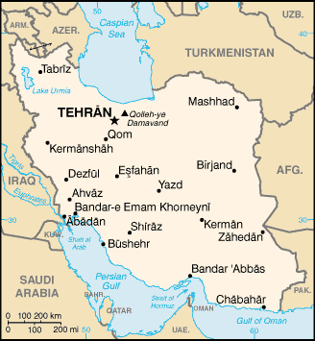
In this last years the Iranian society is subjected to strong social tensions determined by imbalances introduced by the process of industrialization. Made possible by oil revenues, it had enriched only tight circles of business owners and businessmen linked to the court, while millions of peasants crowd the suburbs; hundreds of thousands of intellectuals and students, often westernized and closer to Marxist ideas, resent the repression of dissent by the regime.
Unlike the US and Israeli advisers predicted, however, the spark burns not to material causes and not in the most politicized circles which are the subject of the most careful supervision.
History is the first step to understand what’s happening nowadays; we are probably witnesses of an historical event that will change international relationships.

FROM HISTORY…
At the beginning of the century, Iran was known as Persia and remained neutral during the First World War, while maintaining a state of subordination to Russia and especially to Great Britain. Discovered oil fields in 1919 Iran founded the Anglo-Persian Oil Company: the Qājār’s monarchy gained independence, whilst Britain obtained privileges of a military nature, fiscal and economic.
To complain against the monarchy surrender to the British power, a blight took place and four years later Ridā Shāh was elected as the new Persian Shah.
The same path of Mustafa Kemal in Turkey was taken, divided between repression and modernizing instances: women were imposed to remove their veils, were allowed to go to college without getting right to vote or discrimination’s abolition in field of matrimonial and family law. In addition, secular schools were instituted.
Autocracy, shallow modernization, statalism and repression brought the Shah to give up the religious symbolism, assuming the secular title “Pahlavi”; for the same reasons the country changed its name in “Iran”.
During the Second World War, Iran, historically dependent by Great Britain and URSS, sympathized with the Third Reich; the king was replaced by his son Muhammad Reza, who however failed to allay the conflict between separatists of different ethnic groups, Kurds, nationalists and growing communist parties.
The economic problem became very pressing and the management of oil wealth became the most difficult problem to deal with.
The Anglo-Iranian Company was nationalized, Prime Minister Mossadegh, became the real power holder, signed the decree that challenged the hegemonic role of Britain.
The International Tribunal in The Hague and the United Nations gave way to an economic sanction, poverty increased and Mossadegh tried to prevent reforms and republican ambitions.
British and Americans promoted the nationalization of oil, was resettled Mohammed Reza, who established a dictatorial regime, allied of the West, in a strategically vital Middle East.
Nationalists didn’t like the economic policy of the Shah, the OPEC (Organization of Petroleum Exporting Company) opposed the policy of Israel multiplying by five the price of Arab oil (1973), bringing great wealth to Iran.
Shah, in the grip of pleasure of any kind, declared in 1974 to weekly “Spiegel” that, in a decade, the standard of living would reach the German one; Persia, without infrastructures, bureaucratic and culturally unprepared, fell into serious inequalities among the different social classes.
The Sovereign, completely subservient to President Nixon, just out of the Vietnam War, instituted the SAVAK, a powerful political police "cop of America."
Traditionalists ‘ulamā’ organized protests, strikes and claims of intellectuals, merchants joined the dissidents 'bazari', triggering the fury of the repressive police forces.
… TO NOWADAYS
As we said before, the repressive regime of the Shah Mohammad Reza Pahlavi in the 1970s met a further decline. In an effort to make Iran the primary power in the Middle East, the Shah emphasized the nationalist and autocratic character of his reign, increasing the growing hostility of the Shiite clergy, who had supported him in 1953 (White Revolution).
After the withdrawal of Britain from the Persian Gulf, Iran gained support from the United States and approval for purchase of all types of weapons, with the exception of nuclear. While with the money of industrialization Shah performed inoculated and unnecessary expenses, popular discontent grew. The king decided to respond with force (mass arrests, torture ...). In 1975 the Shah outlawed all political parties.
All forces of opposition to the monarch - faith-based, national-liberal and Marxist – are gathered around the figure of Ayatollah Khomeini, confined in exile since 1963 because of a campaign against land reform. In 1978 massive protests begin, in reaction to a press report of regime that jeering Ayatollah Khomeini, starting a spiral of protests that leads to the block of the country.

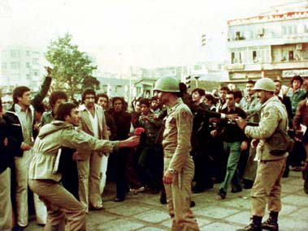

Leaders of the insurgency are at the beginning the fedayeen-and Khalgh, inspired by Marxism, that soon decide to join the Islamist mujahideen to engage in the fight increasingly large sections of the population, broadening the groundwork of the protest. The Shiite clergy soon become the only reference of the uprising overcoming groups of political inspiration.
Exploiting and amplifying a set of events and repressions, fighters are able to increase dissatisfaction of the population.
Khomeini from his exile in Paris incites the revolution, through recorded messages on tapes, which are spread throughout the country, while the Shah performs the last attempt to save his throne by the appointment of Shapur Bakhtiar democratic Prime Minister; he accepts on condition that the king leaves the country temporarily. Reza Pahlavi leaves on January 16, 1979 to Morocco. The population, although enthusiastic about the event, don’t stop the fight, considering the departure of the Shah a further evidence of the weakness and the imminent collapse of the monarchy.
Bakhtiar grants freedom of press, calls for free elections and stops the supply of oil to Israel and South Africa, but Khomeini doesn’t recognize his government and announces his homecoming, which takes place on 31 January 1979. The demonstrations in favor of the Ayatollah multiply; at the same time more and more numerous become the desertions in the army, which on February 11 announces its withdrawal from the fight. Bakhtiar flee.
Khomeini, leader of the revolutionary council, takes real power. On March 30, a referendum marks the birth of the Islamic Republic of Iran; are banned alcohol, gambling and prostitution, the persecution of homosexuals and of anyone assumes behaviors do not conform to Sharia begins. Hand in hand with the Islamization of the country, the unity of the revolutionary front breaks and starts fighting between its various components.

In few months after Islamic Revolution many people are disillusioned, prisons are full of dissidents, airports besiege by people who want to emigrate to avoid ending up a victim of purges of state; Government tries to instill liberticidal principles without success, despite the persuasive use of force, and society opposes by implementing forms of civil resistance and trying to undermine power daily.
A look at Iran's Constitution and at the distribution of powers provides a partial explanation of the situation: the Constitution, albeit founded on “religious" principles, contains many guarantees for citizens, and state offices are elective. However, everything is subordinated to the principle of velayat-e faqih, the government's lawyer: according to this concept, each institution and decision must be brought back, ultimately, to the will of the Supreme Leader (the velayat-e faqih). So here every principle of democracy and popular sovereignty are thus thwarted.
Most of civil society has not already assimilated "religious" dictates given notice, but it seems go in the opposite respect to the parameters that the system continues to dictate. A striking example is the apparel’s dictate: Iranian women are still forced to cover their heads and to observe a certain moderation of clothes when they act in the public sphere, but the majority of women challenge authority adopting "improper" veils: the Iranian girls refute the mandatory imposition of the veil which is not religious, but national.

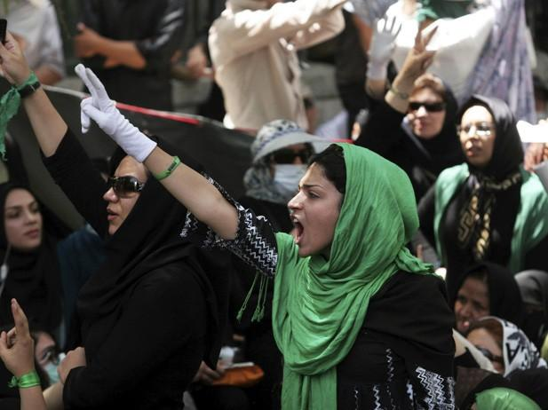
Iran is subject to heavy sanctions and embargo; embargo is defined as a block of trade decided by one or more countries against a third country, usually for political or economic reasons.

To read more:
https://en.wikipedia.org/wiki/Iranian_Revolution
https://en.wikipedia.org/wiki/White_Revolution
http://www.theguardian.com/world/iran
http://search.un.org/?ie=utf8&output=xml_no_dtd&oe=utf8&Submit=Search&__utma=114554307.389033733.1442750035.1442750035.1442750035.1&__utmb=114554307.1.10.1442750035&__utmc=114554307&__utmz=114554307.1442750035.1.1.utmcsr%3Dgoogle|utmccn%3D%28organic%29|utmcmd%3Dorganic|utmctr%3D%28not+provided%29&__utmt=1&_ga=GA1.2.389033733.1442750035&_gat=1&query=islamic+revolution&tpl=un&lang=en&rows=10
http://www.iranchamber.com/history/islamic_revolution/islamic_revolution.php
http://www.britannica.com/event/Iranian-Revolution-of-1978-1979
http://www.aljazeera.com/indepth/features/2014/01/iran-1979-revolution-shook-world-2014121134227652609.html
https://en.wikipedia.org/wiki/Sanctions_against_Iran
https://en.wikipedia.org/wiki/Ruhollah_Khomeini

