Preventing further escalation of the Western-Russian relationship. Security Council
President of Security Council: Neklas Eivig Jørgensen
Vice President: Ilker Isik
Author: Neklas Eivig Jørgensen

Introduction:
The Western-Russian conflict is one of the modern world’s longest rivalries, where the Western nations such as USA and UK oppose Russia in almost every political point of view. The tension dates back to the Cold War, where the Soviet Union and the Western nations opposed each other. Throughout the Cold War the West and Russia supported different sides in various wars, such as the Vietnam War and the Korean War. In recent years, the relationship has deteriorated, mainly due to the Syrian Civil War and the Ukrainian Crisis. The tense relationship between the West and Russia can result in a long-term trade embargo on both sides, which would severely harm the global economy. Furthermore, if the relationship were to deteriorate, fear of a nuclear war would spread throughout the world. Although a heavily debated issue, the United Nations has been unable to pass any significant resolutions on the matter.

What is the issue about?
Almost immediately after World War 2, the winning nations USA, France, UK and the Soviet Union split up the losing Germany in four equal parts. However the differences in the political views, the liberal democratic West and the socialist non-democratic Soviet Union, soon led to disagreements between the western nations; USA, UK and France, and the Soviet Union. This was the beginning of the Cold War. The Cold War lasted from 1947 to 1991 and was called the “Cold” War because no actual fighting took place between the involved nations. However they fought indirectly through supporting opposing sides in various wars and the nuclear arms race. The nuclear arms race, started shortly after USA had developed and used the atomic bomb for the first time. During the nuclear arms race, USA and the Soviet Union developed bigger and bigger nuclear weapons, in a competition to have the most powerful weapon in the world.

In recent years, the relationship between the West and Russia has deteriorated after the beginning of the Ukrainian Crisis. When the sovereignty of the Crimea peninsula in Ukraine got threated, the West accused Russia of forcing the citizens of the peninsula to vote in favour of joining Russia, by employing armed rebels inside Ukraine. Since then, pro-Russian separatists have been fighting the Ukrainian forces with the alleged support of Russia. In response to Russia’s alleged actions, the west put a trade embargo on Russia, which combined with the decreasing oil prices caused a recession in Russia, because of this Russia ended all exports of natural gasses to Europe. These events tensed the relationship significantly.

To make matters worse, the west and Russia have different views on how the Syrian Civil is stopped. The west believe that the current Syrian President Bashar al-Assad must resign or be forcibly removed from the position, whereas Russia believe that Bashar al-Assad is needed in the fight against Islamic State (ISIS). It is broadly believed in the western nations, that the Syrian people need to reunite and end the conflict peacefully without any more bloodshed.

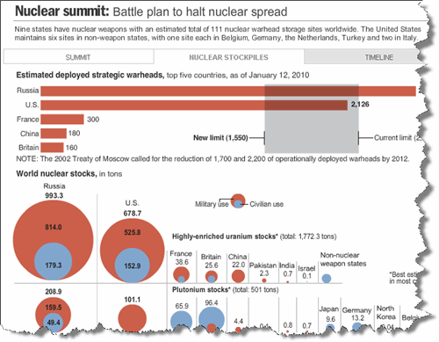

The impact of the relationship
If the relationship were to deteriorate further, it could have massive long-term effects. From an economic point of view, the west could impose a permanent trade embargo on Russia, which would greatly harm the global economy, since Russia is one of the biggest oil and natural gasses exporters in the world. A permanent trade embargo would also start a recession in Russia. Furthermore, as the following diagram will illustrate, the conflict has an influence on the export of the neighbouring Baltic and Eastern European states. Many of the Eastern European and Baltic states export to Ukraine and Russia, which means that an escalation of the crisis, would result in a decrease in the export and thus a decrease in the GDP of those nations. Furthermore it is obvious that many of the Eastern European/Baltic nations are highly dependent on the natural gasses of Russia, which would put them in a bad position, were Russia to end export permanently.

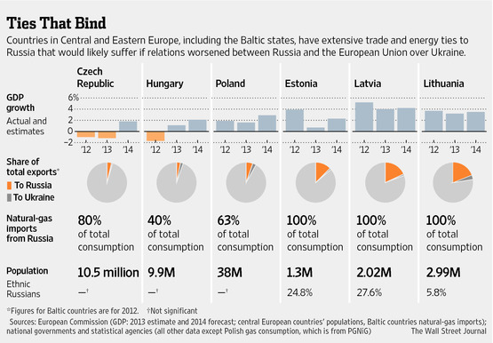

When debating the issue of the Western-Russian relationship, it is important to remember that it would be of interest for most nations to solve the differences, since the conflict generally shines through in every major political crisis in the modern world. An example of this is again the Ukrainian Crisis, where the two opposing political points of view again have resulted in an escalating conflict.

Another important thing to remember is the constant fear of a global nuclear war. With the staggering amount of nuclear weapons in Russia’s and USA’s possession, a nuclear war would be a catastrophic event, which would cause the death of millions if not billions of innocent citizens. This is one of the main reasons why it would of interest for the entire world, to cool down the tension between the two countries and find proper solutions to the aforementioned crises (Ukraine and Syria).

In order for this issue to be properly debated, and a significant resolution to be passed, it is important that the nations are willing to compromise and look at each other’s point of view.

Nations of interest:
- Russian Federation
- United States of America
- United Kingdom of Great Britain and Northern Ireland
- Ukraine
- French Republic
- People’s Republic of China
- Syrian Arab Republic

Read more:
http://www.cnbc.com/2015/05/08/why-russia-us-relations-remain-in-deep-freeze.html
http://www.ecfr.eu/article/commentary_the_origins_of_russias_new_conflict_with_the_west330
http://www.iai.it/sites/default/files/iairp_18.pdf
http://www.globalresearch.ca/the-past-present-and-future-of-russia-west-relations/5415723
http://uk.businessinsider.com/iran-russia-us-relations-after-nuclear-deal-2015-6?r=US&IR=T
http://www.voanews.com/content/ukraine-russia-united-nations-security-council-veto/2966638.html
http://www.historytoday.com/john-swift/soviet-american-arms-race
http://www.bbc.com/news/world-europe-26270866
http://csis.org/ukraine/index.htm
http://www.bbc.com/news/world-middle-east-26248275
http://www.bbc.com/news/world-middle-east-34378889

http://www.bbc.com/news/world-middle-east-34378889

