The handling of Syrian refugees in the adjacent areas.
Security Council
President of Security Council: Neklas Eivig Jørgensen
Vice President: Ilker Isik
Author: Neklas Eivig Jørgensen

Since the Syrian civil war broke out in 2011, it has escalated dramatically with thousands of dead civilians and millions seeking refuge in neighbouring and European countries. Most of the refugees seek shelter in the adjacent nations Republic of Iraq, Arab Republic of Egypt, Lebanese Republic, Republic of Turkey and Hashemite Kingdom of Jordan. Most of the Syrian refugees have received housing in one way or another, however hundreds of thousands of refugees are still living in refugee camps, under bad living conditions. The amount of refugees needing welfare both with and without housing has proven to be a massive burden, on the neighbouring nations. If this issue is not solved soon, it can have massive negative effects on the neighbour countries as well as the Syrian refugees such as but not limited to; recessions, the inability to get asylum and a shortage of resources. This issue has been heavily debated in the United Nations, but with no significant solutions so far.

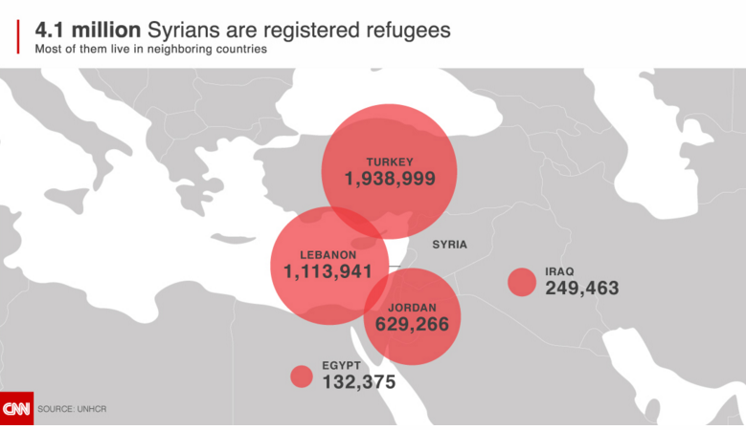

What is the issue about?
Inspired by the Arab Spring and the arrest and torture of a group of teenagers that had painted revolutionary slogans and images on a school wall, a group of Syrians started pro-democracy protests in March 2011 in the Syrian Republic. The protestors were dissatisfied with the current president Bashar al-Assad and demanded democracy and equality. However, when security forces opened fire against the protestors, killing several, more protestors joined. Soon hundreds of thousands of citizens were protesting on the streets on a national scale, all of them demanding the resignation of the president. The government responded with violence, killing several in the process, civilians included. The response of the government caused the protestors, to form armed rebel forces and retaliate thus starting a civil war. The main focus of both sides has from the beginning of the war, been to gain control of cities/areas, thus giving the sides strategic advantages.

However, a civil war does not come without its costs. The armed battles, has resulted in thousands of civilian deaths, many of whom were children. The ever-increasing death count, has led many families to flee the conflict areas. So far more than 4 million Syrians has fled the country and found refuge in either neighbouring or European nations, with an estimated 7.6 million Syrians being displaced from their home inside the country, hence more than 11.5 million Syrians are currently away from their homes, which is approximately half of the country’s pre-conflict population. With a staggering 12.2 million Syrians needing humanitarian assistance inside the country, the conflict has proven to be one of the biggest humanitarian crises in modern history. Most of the displaced left the country or their homes when the conflict escalated and the living standards deteriorated during 2013.

Most of the aforementioned refugees are to be found in the adjacent nations, Republic of Iraq, Arab Republic of Egypt, Lebanese Republic, Republic of Turkey and Hashemite Kingdom of Jordan. The main reason why these nations have the most refugees is because they are neighbouring countries, which makes the passage a relatively safe journey, compared to the journey to Europe. Although many of the refugees in these countries have been placed in houses or apartments, a big part of them are still living in refugee camps, where the living standards are anything but optimal.

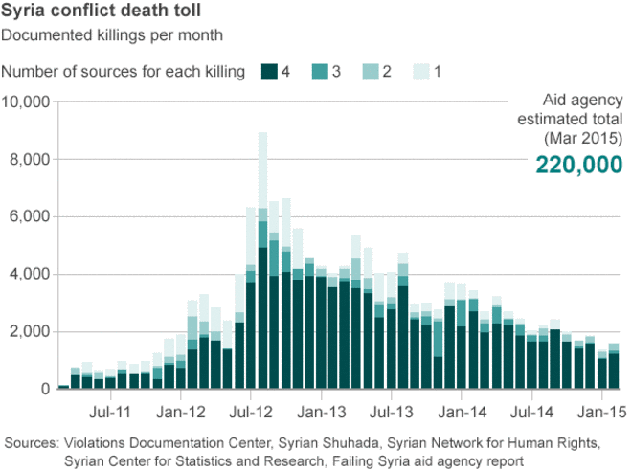

The impact of the crisis
The arrival of hundreds of thousand of refugees would be a burden to any nation in the world. The massive amount of refugees can have long-term effects on the countries. From an economic point of view, the amount of money that the governments have to invest in the welfare of the Syrian refugees puts a huge strain, on the economies of the aforementioned nations. This is mainly due to the fact that the Syrians need shelter, food, water, clothing etc. all things that are relatively scarce resources, and very expensive in large quantities. Furthermore, the refugees who receive housing, such as all the refugees in Arab Republic on Egypt, put a strain on the economy as well. Not only are the governments forced to pay for the housing; they also have to invest in the welfare of the Syrians, by giving them food, water, electricity etc., to ensure their integration in the society.

One of the major issues with the crisis is the different interests at stake. Although most nations can agree that the war needs to be stopped, there are disagreements as to how the war is stopped. Some nations believe that bombing the Syrian government and military will help, whereas other nations believe that other threats such as ISIS should be stopped first. For the European Union (EU), it would be beneficial to prevent the inflow of refugees, something that can only be done by stopping the war from escalating further.

However, the situation is far from optimal for the Syrians either. Although the refugee camps, that are currently housing hundreds of thousands of Syrian refugees, provide shelter, food, water etc., the living standards in those camps are far from good. Many of the Syrians have no or limited access to electricity, clean water and proper housing. They live in tents and have to stand in almost endless lines to get food. To make matters worse, many families have been separated, fathers away from their children, wives who have not seen their husbands in months, the list goes on.

Nations of interest
- Syrian Arab Republic
- Republic of Iraq
- Arab Republic of Egypt
- Lebanese Republic
- Republic of Turkey
- Hashemite Kingdom of Jordan

Read more:
http://data.unhcr.org/syrianrefugees/regional.php

https://www.cia.gov/library/publications/resources/the-world-factbook/wfbExt/region_mde.html

http://syrianrefugees.eu/

http://www.theguardian.com/global-development/2015/mar/11/syrian-refugees-asylum-seekers-unhcr

http://edition.cnn.com/2015/09/09/world/welcome-syrian-refugees-countries/

http://theweek.com/captured/449516/life-inside-syrian-refugee-camps

http://www.bbc.com/news/world-middle-east-26116868

http://www.brookings.edu/blogs/future-development/posts/2015/09/16-economic-impact-refugees-cali

http://www.theguardian.com/global-development/2015/mar/11/syrian-refugees-asylum-seekers-unhcr
http://edition.cnn.com/2015/09/09/world/welcome-syrian-refugees-countries/
http://www.bbc.com/news/world-middle-east-26116868
http://www.bbc.com/news/world-middle-east-26116868
http://www.bbc.com/news/world-middle-east-26116868

