Commission: Commission of Crime Prevention and Criminal Justice
Submitter: Klara-Josefin Ehrnst
Topic: Measures to prevent the illegal sale of guns and weapons on the black market

Introduction
Illegal sale of guns and weapons falls under the term “illicit arms trade”. Illicit arms trade fuels civil wars, adds to high crime rates and makes up the arsenals of the world’s terrorists. Therefore, it is of all member nations interest to prevent illicit arms to enter the black market. It is a government sovereignty right and reusability to remain the central providers of security for its citizens. To succeed remaining the main provider of security, it is essential for their armed and security forces to have access to arms, through domestic production or through imports. Therefore, it is of great importance that the exporters and importers of arms ensure that those arms are transferred and stored safely, instead of ending up in the wrong hands.

Definition of key terms
Black market: Illegal consumption and trade of goods and services which are not allowed to be sold or that there is an excess demand for those goods and services.

Illicit arms: Small arms and light weapons sold illegally.

Small arms: Weapons designed for personal use.

Light weapons: Weapons designed for several people serving as a unit to use it.

Background information
According to the Small arms trade Survey 2017, the international small arms trade was worth approximately USD 6 billion in 2014. This value results from trade between importers and exporters of arms. Therefore, the Small arms trade Survey (SAS) makes a distinction between top exporters and important and major exporters and importers.
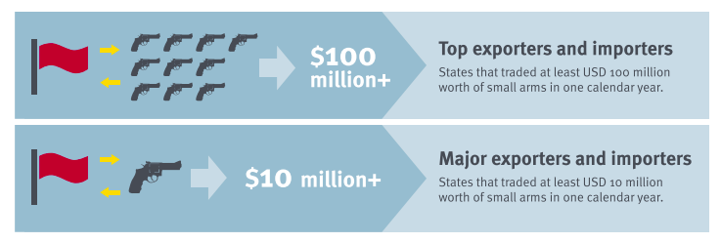
As can be seen in the image above, being a top export or importer means that the country trades at least USD 100 million worth of small arms in one year. While major exporters and importers trade at least USD 10 million worth of small arms in one year.

Top and major exporter of small arms
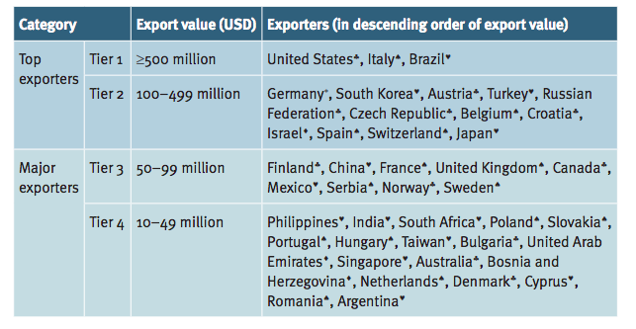
Top and major importers of small arms
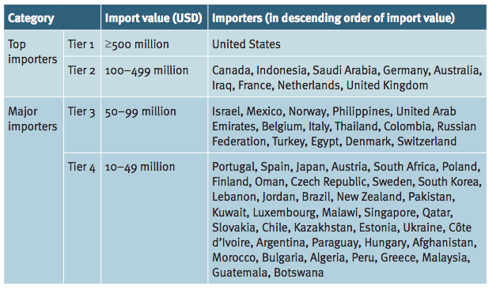
The top and major importers and exporters are of interest since they are responsible for ensuring that their trade does not result in small arms and light weapons ending up on the black market. When small arms and light weapons occur on black markets, it, as mentioned before, contributes to civil wars, high crime rates, and terrorist activities, and thus it results in, not only in large costs for member states but also great suffering.

So, what are some measures to prevent the trade of small arms and light weapons to end up on black markets? The main answer is to provide a safe transportation and storing of arms.
All member states have legal obligations to impose controls on arms transportation in order to prevent unauthorized means of transportation, such as ships and aircrafts, to transfer illegal arms. One way to prevent the transportation is to encourage member states to regulate through national laws sectors closely associated with the trade of small arms and light weapons. Cargo carriers and ship and aircraft owners play a significant role in preventing the illegal trade of arms. In some cases, the ones responsible for the transport of arms have themselves collaborated with unauthorized and unlawful users of arms. Amnesty International suggests that countries should do the following: take measures such as register transport services operating in conflict areas, licensing transport service or activity relating to the trade on arms, make transport services give detailed information on how transportation is taking place when applying for import or export licenses, and require transport services to provide inspection and verifiable documentation.

What has been suggested by the UN in the past, is for member nations to mark small arms and light weapons in order to facilitate the tracking of illicit arms. One method suggested is to mark the arms at right they have been manufactured. This can be done by providing the name of the manufacturer, the country of manufacture, and the serial number. This way, it will be easier to discover an illicit arm. For example, a country should at the time of transferring governmental stocks to civilian use, take necessary measures to mark them in ways that allow for tracing in the future. If a country would find unauthorized arms on their territory, they would have to mark and record them or destroy them. The measures explained above are only some amongst the ones the UN suggests. What they have in common is that they will reduce the illicit arms trade, and thus prevent its effect on wars, crime rates, and terrorism.

Stakeholders
United States of America: As mentioned before, the US is both the top exporter and importer of arms. During the past five years, the US has been exporting approximately half of their small arms and light weapons to war-torn areas in the middle-east. According to the Stockholm International Peace Research Institution, the global transfer of major weapons increased with 10% between 2013 to 2017. The US increased their sale with 25% during this period.

Saudi Arabia: As mentioned before, Saudi Arabia is the second largest top importer of arms. However, more and more countries are suspending their export to Saudi Arabia because they fear that the weapons can be used in Yemen. A Saudi coalition has been engaged in fighting for more than three years in Yemen.

Brazil: The second largest top exporter of arms is Brazil. They have been critizied of exporting weapons to warn-torn areas and regimes such as Yemen. The production of small arms and light weapons is an important source of national income for Brazil. However, it is on the expense of armed conflicts and violent crimes all around the world.

Relevant UN treaties, reports, resolutions:
The arms trade treaty (ATT) ( A/RES/69/49): The ATT aims to regulate the international trade on conventional arms- from small arms to battle tanks, combat aircraft, and warships. It was entered into force on the 24th of December 2014. So far, it has been ratified by 92 countries and signed by 130. Countries such as the US has been criticized for not ratifying it.

International Instrument to Enable States to Identify and Trace, in a Timely and Reliable Manner, Illicit Small Arms and Light Weapons (A/CONF.192/15): A document which includes many possible measures to reduce the illicit arms trade.

The illicit trade in small arms and light weapons in all its aspects (A/71/438–A/CONF.192/BMS/2016/1): A UN report from 2016, regarding the implementation of the “Programme of Action to Prevent, Combat and Eradicate the Illicit Trade in Small Arms and Light Weapons in All Its Aspects”, updated information about the development in small arms and light weapons manufacturing, technology and design. Lastly, the effectiveness and sustainability of financial and technical assistance, including the transfer of technology and equipment, particularly in developing countries.

Possible solutions
All the measures explained under background information will not be as effective if not all countries aim to reduce illicit arms trade. Therefore, it is of great intrest to reach agreements regarding how to deal with the arms trade. According to an article in the Un chronicle, there is no single solution. The article suggests that it is important to close the door between legal and illegal markets and to decrease the demand for small arms and light weapons. The challenge, is, therefore, to agree upon how this is going to be achieved.

What to think about when doing research
- Is your country any of the top or major importer or exporter?
- What laws does your country have regarding manefacturing of small arms and light weapons?
- If you export more than you import, to which countries do you export to? Are any of those countries in a conflict?
- Have your country ratified the ATT? If not, why?
- What are the crime rates related to gun violence in your country?
- What can possible concequences of illicit arms trade be on your country?

Bibliography
BLACK MARKET | Meaning in the Cambridge English Dictionary.” Cambridge Dictionary, dictionary.cambridge.org/dictionary/english/black-market.

“Translations for ARMS TRAFFICKING.” What Does ARMS TRAFFICKING Mean? www.definitions.net/definition/ARMS+TRAFFICKING.

“Small Arms-Related Reports of the Secretary-General – UNODA.” United Nations, United Nations, www.un.org/disarmament/convarms/salw/small-arms-related-reports-of-the-secretary-general/.

Dudley, Dominic. “Why More And More Countries Are Blocking Arms Sales To Saudi Arabia And The UAE.” Forbes, Forbes Magazine, 7 Sept. 2018, www.forbes.com/sites/dominicdudley/2018/09/07/why-more-and-more-countries-are-blocking-arms-sales-to-saudi-arabia-and-the-uae/

Dehghan, Saeed Kamali. “Nearly Half of US Arms Exports Go to the Middle East.” The Guardian, Guardian News, and Media, 12 Mar. 2018, www.theguardian.com/world/2018/mar/12/nearly-half-of-us-arms-exports-go-to-the-middle-east.

“International Instrument to Enable States to Identify and Trace, in a Timely and Reliable Manner, Illicit Small Arms and Light Weapons.” Small Arms Review Conference 2006, The United Nations, 2006, www.un.org/events/smallarms2006/pdf/international_instrument.pdf.

“Deadly Movements: Transportation Controls in the Arms Trade Treaty .” Amnesty International UK, Amnesty International, 2010, www.amnesty.org.uk/files/deadly_movements_-_transportation_controls_in_the_arms_trade_treaty_0.pdf.

Holtom, Paul, and Irene Pavesi. “Trade Update 2017 .” Small Arms Survey, 2017, www.smallarmssurvey.org/fileadmin/docs/S-Trade-Update/SAS-Trade-Update-2017.pdf.

“BLACK MARKET | Meaning in the Cambridge English Dictionary.” Cambridge Dictionary, dictionary.cambridge.org/dictionary/english/black-market.
“Translations for ARMS TRAFFICKING.” What Does ARMS TRAFFICKING Mean? www.definitions.net/definition/ARMS+TRAFFICKING.
“Translations for ARMS TRAFFICKING.” What Does ARMS TRAFFICKING Mean? www.definitions.net/definition/ARMS+TRAFFICKING.
Holtom, Paul, and Irene Pavesi. “Trade Update 2017 .” Small Arms Survey, 2017, www.smallarmssurvey.org/fileadmin/docs/S-Trade-Update/SAS-Trade-Update-2017.pdf.
Holtom, Paul, and Irene Pavesi. “Trade Update 2017 .” Small Arms Survey, 2017, www.smallarmssurvey.org/fileadmin/docs/S-Trade-Update/SAS-Trade-Update-2017.pdf.
Holtom, Paul, and Irene Pavesi. “Trade Update 2017 .” Small Arms Survey, 2017, www.smallarmssurvey.org/fileadmin/docs/S-Trade-Update/SAS-Trade-Update-2017.pdf.
Holtom, Paul, and Irene Pavesi. “Trade Update 2017 .” Small Arms Survey, 2017, www.smallarmssurvey.org/fileadmin/docs/S-Trade-Update/SAS-Trade-Update-2017.pdf.
“Deadly Movements: Transportation Controls in the Arms Trade Treaty .” Amnesty International UK, Amnesty International, 2010, www.amnesty.org.uk/files/deadly_movements_-_transportation_controls_in_the_arms_trade_treaty_0.pdf.
“International Instrument to Enable States to Identify and Trace, in a Timely and Reliable Manner, Illicit Small Arms and Light Weapons.” Small Arms Review Conference 2006, The United Nations, 2006, www.un.org/events/smallarms2006/pdf/international_instrument.pdf.
Dehghan, Saeed Kamali. “Nearly Half of US Arms Exports Go to the Middle East.” The Guardian, Guardian News, and Media, 12 Mar. 2018, www.theguardian.com/world/2018/mar/12/nearly-half-of-us-arms-exports-go-to-the-middle-east.
Dudley, Dominic. “Why More And More Countries Are Blocking Arms Sales To Saudi Arabia And The UAE.” Forbes, Forbes Magazine, 7 Sept. 2018, www.forbes.com/sites/dominicdudley/2018/09/07/why-more-and-more-countries-are-blocking-arms-sales-to-saudi-arabia-and-the-uae/
“Small Arms-Related Reports of the Secretary-General – UNODA.” United Nations, United Nations, www.un.org/disarmament/convarms/salw/small-arms-related-reports-of-the-secretary-general/.

