Official Report of EGMUN 2018
TOPIC: The question of establishing an agreement on the creation and regulation of Artificial Intelligence
Committee/Commission: Commission on Science and Technology for Development
Main Chair: Federico Poccioni – poccionifederico@gmail.com
Deputy Chair: Anna Mathiasen – annaraumathiasen@gmail.com

Introduction
The importance of Artificial Intelligence in our society is growing as fast as ever expected: it is progressively replacing many routine jobs that deal with production and treatment of objects, calculation, translation, logistics and more. Most of the industrial occupations will be replaced by computer-based facilities that one day could even repair themselves without technical human help. Even the idea of industry, with the rise of computer managed 3D printers, will completely change when customers would have the possibility to produce objects with their own printer without anyone’s help by simply downloading or even creating the entire project on a computer. In general, AI is supposed to change mankind’s life in every aspect, like a new industrial revolution. However a great potential is always followed by multiple risks, most of them based on how powerful those AI could be and how can we keep them in control without limiting their functionalities. If we give the AI too much self-control, the danger of being hacked by possible terrorist groups will be quite impossible to manage and it will cause a lot of damage to the entire planet. Therefore UN’s task is to find a worldwide agreement on this matter, focusing on what kind of security measures should we set and in which way AI is going to be used by the MEDCs.
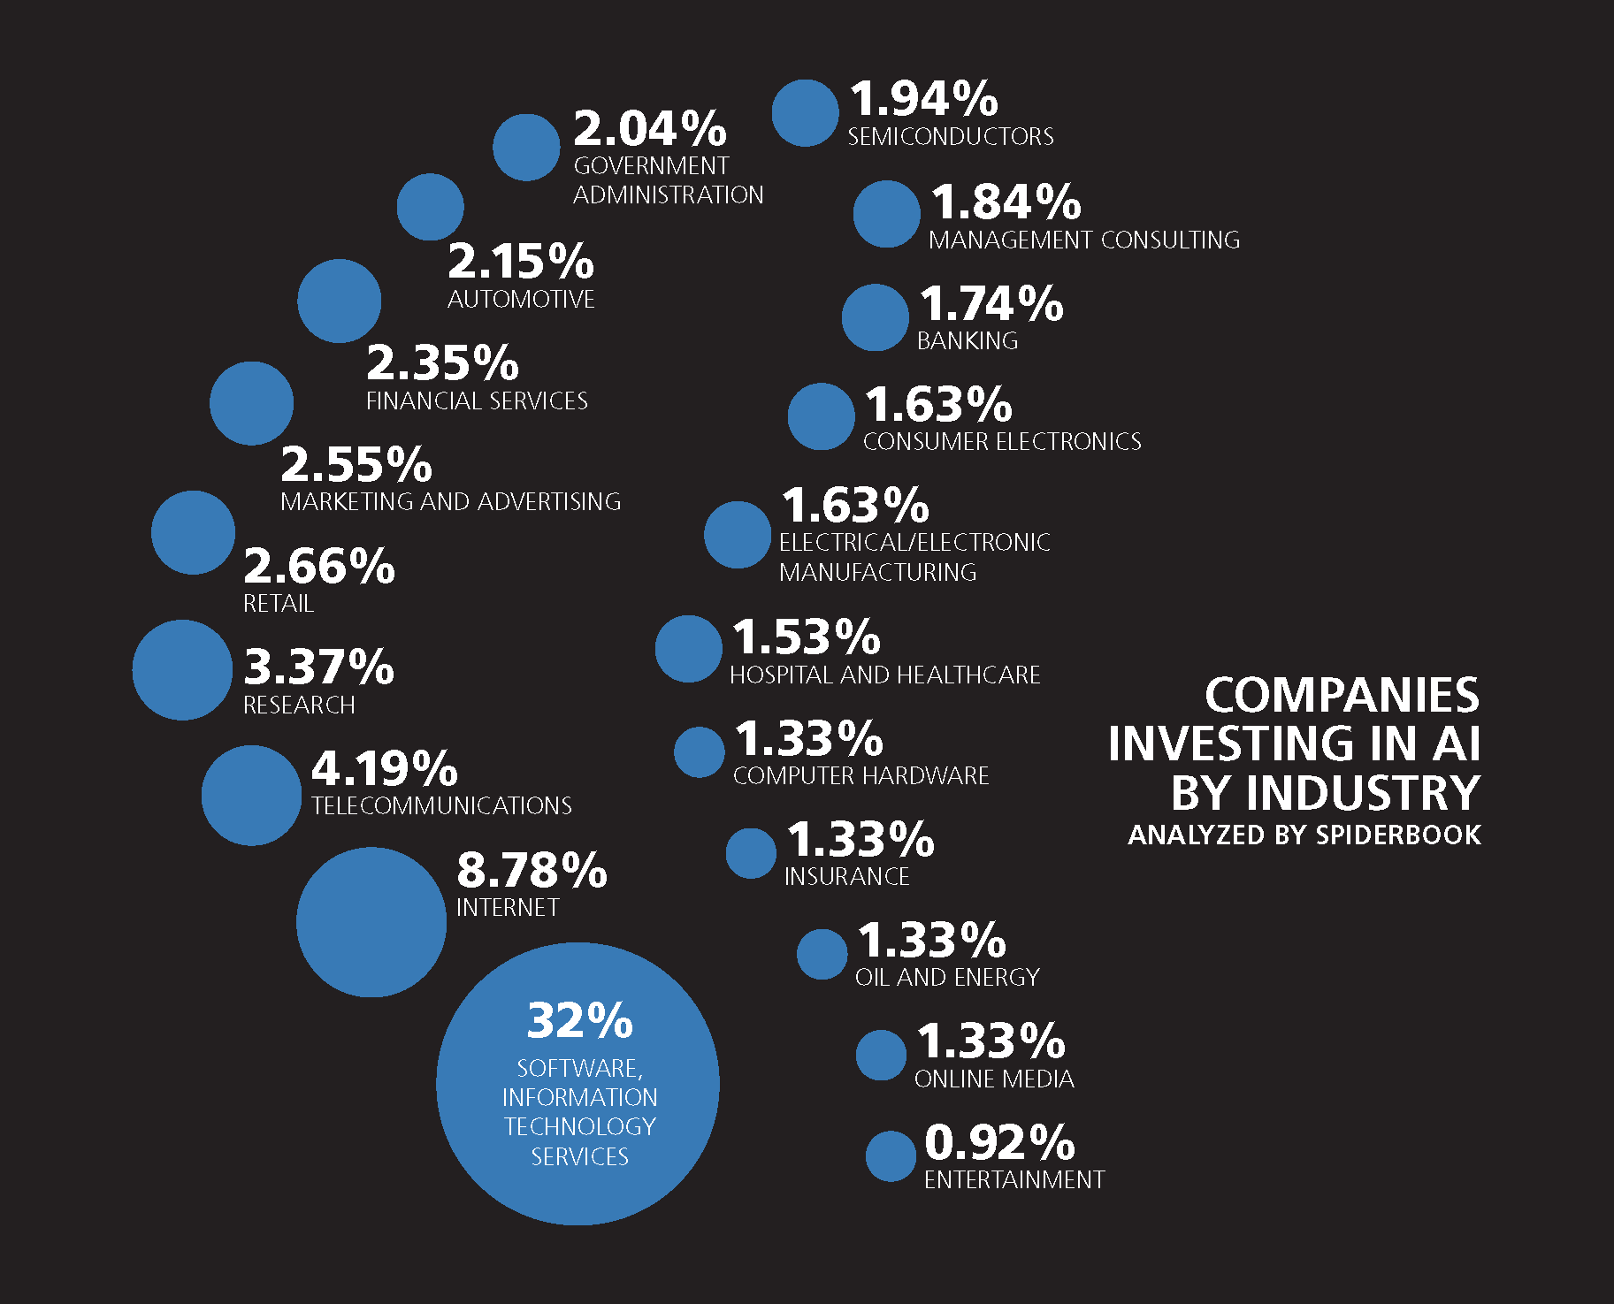
Part I: Definition, origins and current application of an AI
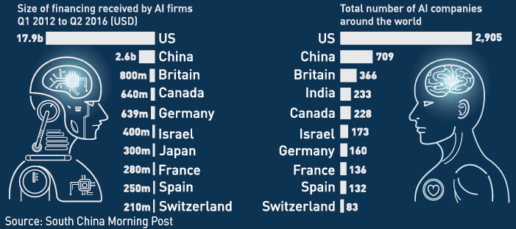
The Artificial Intelligence is defined as the intelligence shown by a machine, most specifically any device that perceives its environment and takes actions that maximize its chance of successfully achieving its goals. AI basically mimics cognitive functions that are associated with human minds, such as “learning” and “problem solving”. The term was applied for the first time in 1956 as an academic discipline where students and scientists worked on the possibility to develop machine’s intelligence using mathematical data as the main language. Keeping our attention on the practical aspect of the issue, AI lived periods of optimism and even negative ones with a strong funding decrease. However, after more than 30 years of studies, the first important achievements were reached: a new research field called “Deep Learning” was born in order to study the way a machine can complete a task from multiple levels and characteristics, the first personal computer with digital interface was created by Macintosh, Microsoft launched his operative system “Windows”, et cetera. The revolution of human activities was just begun. AI started evolving in the most common items we use everyday and currently, thanks also to the internet, it helps us do deal with multiple tasks at the same time and made some of them easier than ever. Credit cards, for example, are a suitable demonstration of how AI made our life easier in some important tasks like payments, even though now in countries like China you can buy something by simply reading the QR code of the product with a mobile phone, directly connecting your bank account with the operation you requested. In the USA, AI also manages many logistics companies such as FedEx, where deliveries are made by drones who are programmed to deliver any product to the customer. In general, AI are fundamental for companies in order to solve practical issues in short time with great efficiency, and since so AI’s influence in companies’ affairs will increase by 20% within 2020. By the way USA and China, as mentioned below, are two of the most active investors in the field of AI development. The next graphic shows some data about this situation.

Part II: How would AI change society and which risks should we prevent from becoming dangerous
Currently the AI is applied in most of the computer-based devices, in many internet and digital companies (Google, Microsoft, Apple et cetera), and even in some banking operative systems. However, AI’s potential is massive: every practical work could be soon replaced with working machines managed by an autonomous AI, accounting, finance and general administration could be soon managed by a single Artificial Intelligence. The risks to suffer this changes are quite serious: replacing human workforce with machines would mean to leave more than 60% of the population with no job at all. But, according to Google China CEO Kai-Fu Lee, this aspect would represent a problem in short term, since within 10/15 years there would be the necessity of

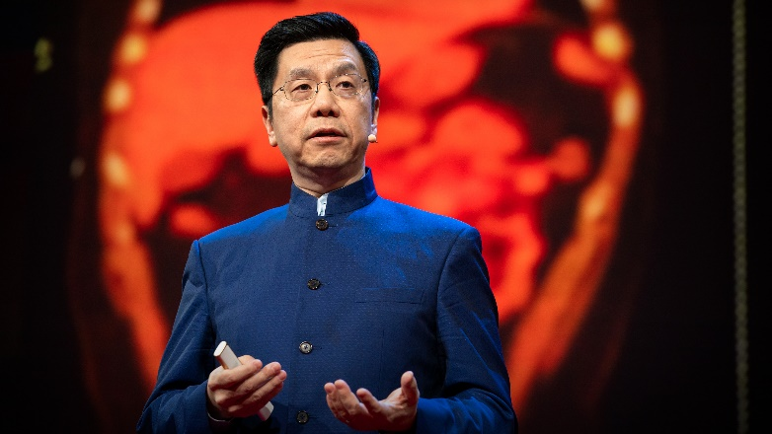
those workers to find a new occupation, but an important advantage for mankind’s liberty of thought. In fact Lee strongly believes this process will let the people get more time to think efficiently, to solve important social issues and no more practical ones (where AI will work), to stimulate creativity and compassion between human beings, getting more time to public and social relations. But there are dangers related to giving AI so much autonomy that must be prevented in order to avoid a potential crisis and, worse, a war. First of all AI must be ready to face possible hacks, strengthening its security systems and keeping their server rooms locked with exclusive access, but, as we don’t know how strong this hacking attack might be, AI should have some other emergency systems such as security automatic shutdown. This aspect made many engineers think that AI must never gain too much autonomy and it should always be able to be managed in order to solve any kind of possible danger or breakdown. Therefore the UN has called upon to find an agreement in this matter, so that all the member states will be aware of what dealing with AI means and in which way should they carry on with AI researches.
“AI will come and take away the routine jobs, and in due time we will be thankful”
Kai-Fu Lee
TED’s Talks conference
Aug 27th 2018

TIMELINE AND GLOSSARY
Timeline
- 1956: AI research officially started
- 1980: After the AI winter, the first analytical skills simulator was born
- May 11th 1997: Deep Blue defeated chess champions for the first time, taking a great leap forward to the future of AI
- 2011: An IBM question answering system called “Watson”, defeated two experts in a famous quiz show called “Jeophardy!”
- 2012: Microsoft launches Kinect, a 3D reader that can simulate human body movement on a gaming console exploiting AI’s latest discoveries about reality perception of AI
- 2013-Pres.: Google, Apple and Microsoft developed their own AI assistant
- 2018: The Pentagon announces project JEDI (Joint Enterprise Defense Infrastructure), a multi-billion dollar cloud computing project who will deal with an unimaginable amount of data. Companies like Amazon, Microsoft and Oracle are eyeing the project, when instead Google refused the invitation of the Pentagon due to “ethical matters within our workers”. This project would treat also classified Data.
Glossary
- AI: intelligence demonstrated by machines, in contrast to the natural intelligence displayed by humans and other animals. In computer science AI research is defined as the study of "intelligent agents": any device that perceives its environment and takes actions that maximize its chance of successfully achieving its goals.
- Deep Learning: part of a broader family of machine learning methods based on learning data representations, as opposed to task-specific algorithms. Learning can be supervised, semi-supervised or unsupervised.
- Hacker: any skilled computer expert that uses their technical knowledge to overcome a problem. While "hacker" can refer to any skilled computer programmer, the term has become associated in popular culture with a "security hacker", someone who, with their technical knowledge, uses bugs or exploits to break into computer systems.

Part III: Public opinions and previous UN’s actions on the matter
AI’s past, present and future has been frequently mentioned and discussed in most of the main scientific conferences as a very doubtful topic since, as we already mentioned, its potential is as big as its risks. Furthermore in this section we’re going to take a look at some opinions by experts and politicians in order to comprehend better the way those devices could work in its positive and negative ways.
Space X’s founder and CEO Elon Musk during a debate with Sci-Fi novel writer Johnathan Nolan mentioned the fact that people are worried about AI’s potential abilities because they’re actually afraid about being overcome by them, thinking that AI may become smarter than human beings. Musk also affirms that AI could potentially be far more dangerous than any nuclear winter if it’s not managed and developed in the right way. The main issue is how carefully should humanity work in the creation of a super-intelligent AI, and according to most of the scientists this issue is too important for the entire planet: the fastest we work on AI the more we risk to start a new potential crisis, the slower we work on it the slower we may resolve important tasks for mankind’s wellness.
Microsoft CEO Satya Nadella has instead less worries about AI’s potential and with the opening of MAIA (Microsoft Artificial Intelligence Academy) the company did a great leap forward on the development of smarter AIs and their application in the new frontiers of technology such as the advanced reality. With their successful cloud service and their well-known devices, Nadella is supposed to increase funding for the AI research and creation with no important financial risks for its company.
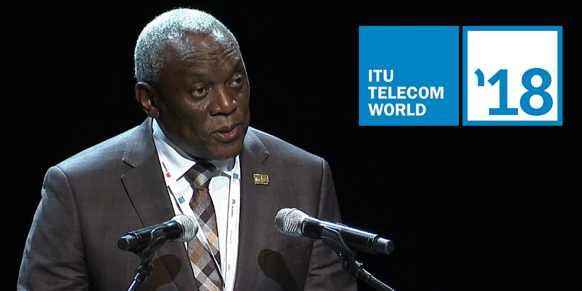
Currently, after ITU (International Telecommunication Union) conference in Geneva on May 2018, the UN section stresses the importance of the benefit AI could bring on the question of sustainable development and reduction of wastes in the planet for environment. The teams joining the conference proposed impactful AI strategies able to be enacted in the near term, guided by an expert audience of mentors representing government, industry, academia and civil society. Those solutions were evaluated to those mentors according to their feasibility and scalability, potential to address truly global challenge, degree of supporting advocacy, and applicability to market failures beyond the scope of government and industry. The task connected AI innovators with public and private sector decision-makers, building cooperation to take promising strategies forward.
ITU Telecom World 2018 in Geneva
South Africa's Minister of Telecommunications and Postal Services Siyabonga Cyprian Cwele giving his agreement on ITU’s strategy for AI’s development and offering to host the next conference in his country

Bibliography and Useful Links

https://www.ted.com/topics/ai
https://www.bbc.com/news/topics/ce1qrvleleqt/artificial-intelligence
https://www.forbes.com/sites/cognitiveworld/2018/10/24/if-establishing-an-ai-strategy-is-proving-troublesome-do-this/#2036a1596673
https://www.youtube.com/watch?v=ajGgd9Ld-Wc&t=5s
https://www.information-age.com/artificial-intelligence-machine-learning-data-science-123475834/

