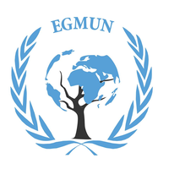
Official Report of EGMUN 2018
TOPIC: The question on the use of nuclear energy to sustain growth and development in LEDCs and other nations interested in the source of power
Committee/Commission: Commission on Science and Technology for Development
Main Chair: Federico Poccioni – poccionifederico@gmail.com
Deputy Chair: Anna Mathiasen – annaraumathiasen@gmail.com

Introduction
In a period where we’re paying damages of polluting resources exploited by the society, the research of sustainable and renewable energy is getting quite important to secure a better tomorrow for our children and our planet. The most recent discover about potential sustainable and renewable energy sources is related to the nuclear fusion and division. The great amount of power we can take from these reactions is known as nuclear energy. Currently the worldwide generation of electricity includes a 12% part gained with the exploitation of nuclear energy, and according to IAEA, it must reach the 30% within 5 years in order to obtain successful achievements on the matter of sustainable development. Nevertheless, working on nuclear energy has a high cost, not only in economic terms, but even in issues related to environmental conditions and possible technical accidents that could seriously damage the territories close to the power plant. When most of the MEDCs already built nuclear power plants in their countries, the LEDCs have quite more problems in doing it, but with the cooperation between other developed countries they could get many advantages in order to restore a good economic stability. Furthermore the task is to find a common agreement about this project of nuclear power plants construction and to raise awareness of potential and risks of this plan among the member states.
Part I: From its discover to its current application. What is Nuclear Energy?
Nuclear Energy is defined as the generation of heat released by nuclear reactions, this heat is then used in steam turbines to produce electricity in the nuclear power plants. With the discover of the nuclear reactions during the thirties, the first application was meant to strengthen military firepower in case of a new war (since the political relationships between the twenties and the thirties were critical and easy to end with a conflict). With the Manhattan Project, USA officially started a chain reaction were the main powers of the world (for example France, United Kingdom and USSR) begun the same research on the matter of the creation of powerful nuclear weapons. However, countries like USSR, Canada and UK built the first nuclear power plants during the fifties in order to produce electricity, and moving on to the sixties and the seventies most of the European and middle-east countries built at least a power plant. This new way of getting electricity brought enthusiasm within the science and technology department, and with the creation of the IAEA (International Atomic Energy Agency) the member states started cooperating to develop new technologies and security systems for those power plants. Nevertheless this nuclear golden age ended with the accidents of Three Mile Island and Chernobyl, with thousands of civilian killed by the explosions and most of them by the radioactive wastes that infected all the nearby territories. These catastrophes immediately stopped the construction of new power plants in all the states. By the end of the 1970s it became clear that nuclear power would not grow nearly as dramatically as once believed. Eventually, more than 120 reactor orders in the United States were ultimately cancelled and the construction of new reactors ground to a halt. Oppositions were set in Ireland, Netherlands and Poland; meanwhile in Austria, Sweden and Italy voted in referendums to phase out their nuclear programs. With the end of the cold war and the beginning of the 20th century, new opportunities for nuclear energy were set 2010 almost all the member states restarted the nuclear program, constructing new power plants; the NATO’s Nuclear sharing program was launched by the US, and currently nuclear energy is an improving scientific field that is going to be fundamental for the development of a more sustainable life for all the cities and countries. 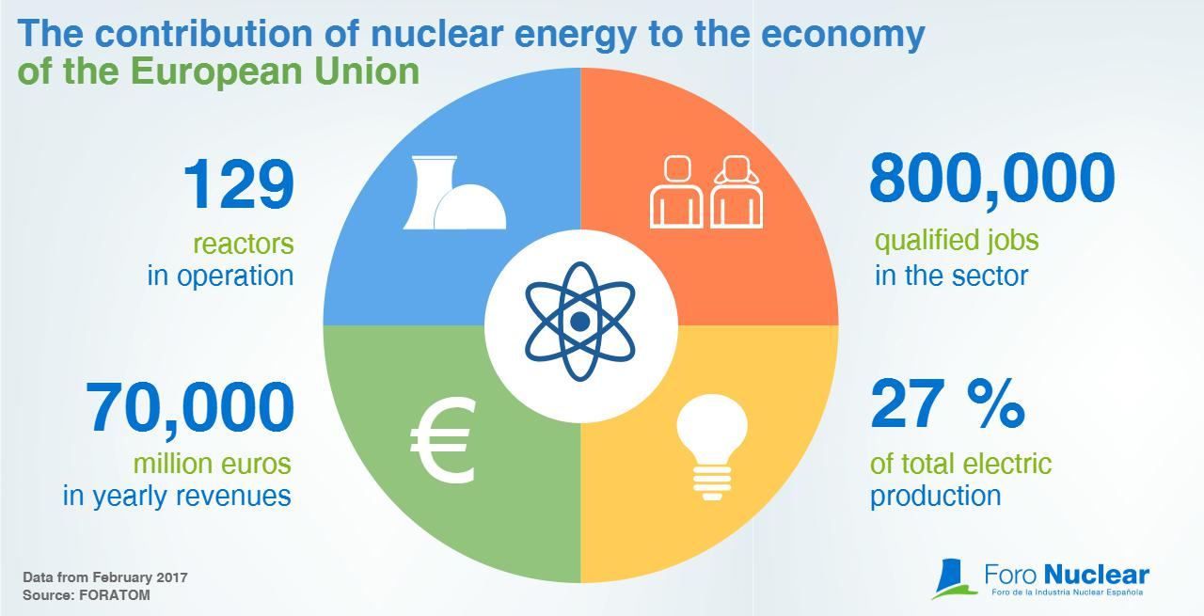
Part II: How can we promote nuclear energy without risk?
The main reason why nuclear energy is not very common yet is strictly related to its safety: many states in Asia and the pacific have already refuse the possible idea of constructing nuclear power plants, and even states which already have one or two power plants currently don’t want to add more. Even though the risks have been reduced since Chernobyl, some states are afraid to risk such a grave accident again and are not really convinced about nuclear energy’s safety. The UN must in fact focus on the potential risks of a nuclear power plant’s construction and on the safety checks and security system it must adopt to reduce his potential damage to the people and the environment. Another issue, probably the most important to our task, is that LEDCs are not interested in constructing nuclear power plant because it could be a waste of money that are probably more necessary for other purposes. However, if LEDCs would be aware of the opportunities these plants can offer, they could improve their economy with them, offering a new sector for qualified jobs in the country to raise occupation and re-arrange the inner market. These two are the most important tasks on this matter.
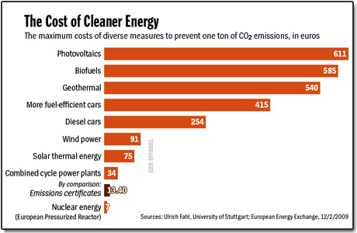
TIMELINE AND GLOSSARY

TIMELINE
- 1940: In the United States, where Fermi and Szilárd had both emigrated, the discovery of the nuclear chain reaction led to the creation of the first man-made reactor, known as Chicago Pile-1, which achieved criticality in December 1942
- August 1945: the first widely distributed account of nuclear energy, in the form of the pocketbook The Atomic Age, discussed the peaceful future uses of nuclear energy and depicted a future where fossil fuels would go unused.
- 1953: American President Dwight Eisenhower gave his "Atoms for Peace" speech at the United Nations, emphasizing the need to develop "peaceful" uses of nuclear power quickly. This was followed by the 1954 Amendments to the Atomic Energy Act which allowed rapid declassification of U.S. reactor technology and encouraged development by the private sector.
- June 27, 1954: the USSR's Obninsk Nuclear Power Plant became the world's first nuclear power plant to generate electricity for a power grid, and produced around 5 megawatts of electric power.
- The 1973 oil crisis had a significant effect on countries, such as France and Japan, which had relied more heavily on oil for electric generation (39% and 73% respectively) to invest in nuclear power.
- 1979: Accident at Three Mile Island
- 1986: Accident at Chernobyl
- 2009: Many nations such as UK, Italy, Turkey and Poland reprise their development of nuclear plants interrupted after the nuclear disaster in Chernobyl

GLOSSARY
- Nuclear Energy: The use of nuclear reactions that release nuclear energy to generate heat, which most frequently is then used in steam turbines to produce electricity in a nuclear power plant. Nuclear power can be obtained from nuclear fission, nuclear decay and nuclear fusion.
- Nuclear Power Plant/Nuclear Reactor: Nuclear facility meant to produce electricity with the heat generated by nuclear reactions.
- Nuclear Disaster: Any catastrophic event caused by nuclear accident or war, it has a devastating potential that can threaten mankind itself.
- Nuclear Winter: A possible scenario where nuclear disasters strongly damaged the entire planet. It has been defined during the cold war, where a nuclear conflict between USA and USSR was expected to happen.
Part III: UN’s recent actions and sections
As we mentioned before, the IAEA is recognized as the most important section of the UN dealing with nuclear energy. It works with its Member States and multiple partners worldwide to promote the safe, secure and peaceful use of nuclear technologies. The IAEA’s relationship with the United Nations is guided by an agreement signed by both parties in 1957. It stipulates that: “The Agency undertakes to conduct its activities in accordance with the Purposes and Principles of the United Nations Charter to promote peace and international co-operation, and in conformity with policies of the United Nations furthering the establishment of safeguarded worldwide disarmament and in conformity with any international agreements entered into pursuant to such policies.” Currently the 193‑member Assembly took note of several resolutions recently approved by the Vienna‑based IAEA. Those texts were aimed at strengthening international cooperation in areas including nuclear science, technology and nuclear, radiation, transport and waste safety. The Assembly also took note of several IAEA resolutions on the application of nuclear safeguards in the Democratic People’s Republic of Korea and the Middle East, while reaffirming its strong support for the Agency’s activities. In addition, it welcomed a resolution on the approval of the appointment of Yukiya Amano as Director General of the Agency from 1 December 2017 to 30 November 2021.
Many delegates, including those from India and the Russian Federation, commended IAEA for assisting developing countries in related development programs China’s representative said that with the recent adoption of the 2030 Agenda for Sustainable Development and the Paris Agreement on Climate Change, nuclear energy would play an increasingly important role in the generation of energy around the world. After adopting a draft resolution about it, no more important decisions were made and, as mentioned by many European states’ delegates, there’s a lot more yet to be discussed.
Bibliography and Useful Links
https://www.forbes.com/sites/jamesconca/2016/03/24/is-nuclear-power-a-renewable-or-a-sustainable-energy-source/#540ec967656e
http://www.world-nuclear.org/information-library/country-profiles/others/emerging-nuclear-energy-countries.aspx
https://www.iaea.org/sites/default/files/26105380308.pdf
https://www.pri.org/stories/2012-12-16/nuclear-power-developing-countries-let-s-talk-about-it
https://www.amacad.org/content/publications/pubcontent.aspx?d=860
https://www.un.org/press/en/2017/ga11972.doc.htm

