ESPERGÆRDE GYMNASIUM
BOOKLET 2018
MODEL UNITED NATIONS
14th to 18th of November 2018
TABLE OF CONTENT

1
Welcome to EGMUN 2018............................................................................................................. 2
Schedule.......................................................................................................................................... 3
Wednesday 14th of November................................................................................................... 3
Thursday 15th of November....................................................................................................... 3
Friday 16th of November............................................................................................................ 4
Saturday 17th of November........................................................................................................ 4
Sunday 18th of November.......................................................................................................... 4

The Secretariat................................................................................................................................ 5

Chairs and Presidents...................................................................................................................... 6

EGMUN 2018 Agenda - GA............................................................................................................. 7

EGMUN 2018 Agenda – ECOSOC………........................................................................................... 8

EGMUN 2018 Agenda - SPECIAL FORUMS..................................................................................... 9

Delegate Information.................................................................................................................... 10
Ambassadors............................................................................................................................ 10
Badges...................................................................................................................................... 10
Dress Code............................................................................................................................... 10
Notepaper................................................................................................................................ 10
Approval Panel......................................................................................................................... 10
Punishments............................................................................................................................. 10
Smoking and alcohol................................................................................................................ 11
Photocopying and printing facilities........................................................................................ 11
The Secretariat......................................................................................................................... 11
Accommodation....................................................................................................................... 11
Transportation - the local train systems.................................................................................. 12
Property of EG.......................................................................................................................... 12
Party......................................................................................................................................... 12
Meals........................................................................................................................................ 12
Emergencies............................................................................................................................. 13
Espergærde Gymnasium Model United Nations 2018. Session XVI
EGMUN’s Directors.................................................................................................................. 13
Rules of Procedure................................................................................................................... 13

Directions...................................................................................................................................... 14
Participating schools..................................................................................................................... 17
Special thanks to................................................................................................................. ......... 18
Rules of Procedure………………………………………………………………………………………………………………….19

WELCOME TO EGMUN 2018

Dear delegates, chairs, press and news corps, administrative staff and MUN- directors, we hereby welcome you to this year’s Espergærde Gymnasium Model United Nations!

In collaboration with our Executive Staff we have been working hard on planning this year’s conference, and cannot wait for it to finally get started! We look very much forward to all of you experiencing what we have prepared for our Session XVI.

We are delighted to see you all and look very much forward to hear your exciting debates and sustainable political solutions. Most of all, we are incredibly excited to once again see the MUN-spirit fill the corridors of Espergærde Gymnasium.

We hope to live up to your expectations and to make this EGMUN better than ever before!

Best regards,

Conference Manager, Linus Poulin Midtgaard
Conference Manager, Lærke Laura Bæk Nielsen
SCHEDULE

3

Wednesday 14th of November

11:00 - 11:45 Arrival and registration, Kulturværftet, Allegade 2, 3000 Helsingør.

11:50 All attendants be seated

11:55 President calls for order

12:00-12:30 Speeches by:

- Principal of Espergærde Gymnasium,
Henrik Boberg Bæch
- Secretary General of EG-MUN 2018,
Andreas Rantzau
- Professor of International Politics
Mikkel Vedby Rasmussen

12:30 – 12:35 Official opening of EG-MUN 2018.

12:35 – 13:00 Coffee break.

13:00 - 13:45 Ambassador speeches.

13:45 - 14:00 Practical information.

14:15 – 14:50 Reception/refreshments.

15:00 Closure

Thursday 15th of November
Espergærde Gymnasium Model United Nations 2018. Session XVI

8:30 - 9:00 Chair meeting in the Secretariat
9:00 MUN-directors’ breakfast at the faculty lounge / “lærerværelset”
9:00 - 17:00 Ad hoc session in every forum followed by lobbying time

Lunch break:
12:15 – 12:45 Lunch at Bjarne’s: 1st, 2nd, 3rd committee, CWS, CSTD, SC & HSC
13:00 - 13:30 Lunch at Bjarne’s: 4th, 5th, 6th committee, CCPCJ, UNEP & CC

Evening Free
18:00 MUN-directors’ dinner at Louisiana
Friday 16th of November

Morning Free
13:40 - 14:00 Chair meeting in the Secretariat
14:00 - 20:00 Lobbying time in forums/ forums in session
(Decision made by the chairs)

Dinner:
17:15 - 17:45 Dinner at Bjarne’s: 4th, 5th, 6th committee, CCPCJ, UNEP & CC
17:45 - 18:15 Dinner at Bjarne’s: 1st, 2nd, 3rd committee, CWS, CSTD, SC & HSC

Saturday 17th of November

8:30 - 9:00 Chair meeting in the Secretariat
9:00 – 17:00 Forums in session

Lunch break:
12:15 - 12:45 Lunch at Bjarne’s: 1st, 2nd, 3rd committee, CWS, CSTD, SC & HSC
13:00 - 13:30 Lunch at Bjarne’s: 4th, 5th, 6th committee, CCPCJ, UNEP & CC

20:30 - 01:00 The official EGMUN party at Espergærde Gymnasium & HF

Sunday 18th of November

9:45 - 10:00 Chair meeting in the Secretariat
10:00 – 13:15 General Assembly
- All committees of the GA (1st, 2nd, 3rd, 4th, 5th & 6th)
Assembly of the Economic and Social Council
- All Commissions of the ECOSOC (CWS, CCPCJ, CSTD)
UNEP, SC, CC and HSC in session

Lunch break:
12:15 - 13:15 Lunch at Bjarne’s: ECOSOC, UNEP, SC & CC
13:15 - 14:15 Lunch at Bjarne’s: Committees of the General Assembly & HSC

14:30 – 17:00 Closing Ceremony at Espergærde Gymnasium & HF
The official closing of:
ESPERGÆRDE GYMNASIUM MODEL UNITED NATIONS 2018
THE SECRETARIAT

5

Secretary General Andreas W.A. Rantzau
sg@egmun.org

Vice Secretary General & Joachim Levin Thomsen
President of the General Assembly

Conference Managers Linus Poulin Midtgaard
cm@egmun.org (+45 26 24 16 49)
Lærke Laura Bæk Nielsen
(+45 24 61 79 49)

Financial Manager Christian Due
fm@egmun.org

Accommodation Managers Casper Lygum
Lygum123@gmail.com Silje Hast

Head of Staff Nina Lerche Jeberg

Head of Press Anna Roberts
Head of Media Andrea Marschall
Kamila Hallengren

Event Manager Villads Rostrup
(+45 29 73 13 24)

MUN-Directors Rolf Mortensen
(rm@eg-gym.dk)
Thomas Rasmussen
Espergærde Gymnasium Model United Nations 2018. Session XVI
(hr@eg-gym.dk)
CHAIRS AND PRESIDENTS

Chairs of the committees of the GA
1st Committee Main Chair: Roser Perez Parcerisas
Deputy Chair: Nina Løvengreen

2nd Committee Main Chair: Evan Mark Corser-Tiernan
Deputy Chair: William Østil Thøgersen

3rd Committee Main Chair: Amanda Wullfeld
Deputy Chair: Andreas Løvengreen

4th Committee Main Chair: Rikke Storgaard Thomsen
Deputy Chair: Mathilde Boye

5th Committee Main Chair: Anton Brøndum Reeh
Deputy Chair: Rebin Nerway

6th Committee Main Chair: Emma-maia Tofft
Deputy Chair: Lorenzo Coscione

Chairs of the commissions of the ECOSOC
Commission on the Status of Women Main Chair: Rebecca Nicole Bigum Slatcher
Deputy Chair: Amalie Thorsen

Commission of Crime Prevention and Main Chair: Klara-Josefin Ehrnst
Criminal Justice Deputy Chair: Kristina Mathilde Jensen

Commission on Science and Technology Main Chair: Federico Poccioni
for Development Deputy Chair: Anna Mathiasen

Chairs and presidents of the other forums of EGMUN 2018

United Nations Environmental President: Andrea Selvatici
Programme Vice President: Jasmin Kaur

Crisis Committee President: Mariya Gogenko
Vice President: Justin Weaver

UN Security Council President: Filippa Hemmerstorp
Vice President: Frederik Lysgaard
UN Historic Security Council President: Elizabete Isakssone
Vice President: Ida Mørch
EGMUN 2018 AGENDA - GA

7

1st Committee:  Disarmament and International Security (DISEC) | The question of nuclear disarmament on a global basis | Measures to provide diplomatic aid to the ongoing Israel-Palestine conflict | The issue of chemical weapons still being used for warfare.
2nd Committee:  Economic and Financial (ECOFIN) | The question of reducing financial inequality in LEDC’s and other countries that experience problems related to this matter | Measures to prevent and reduce tax evasion | The question of providing aid to the still worsening economy of Venezuela
3rd Committee:  Social, Humanitarian and Cultural (SOCHUM) | Measures to ensure human rights and improve living conditions for children in low income areas | Securing rights and improving conditions for refugees | Taking further action to prevent the trading of illegal goods and services on the dark web
4th Committee:  Special politics and Decolonization (SPECPOL) | The question of countering white supremacism around the globe | The matter of establishing rights for the LGBT community | The issue regarding the situation in Tibetan
5th United Nations Development Programme (UNDP) | Ensuring clean drinking water to all people | Ensuring the possibility of education to all children in LEDC’s | Securing ocean life by seeking to have countries limit their pollution and stop overfishing the seas.
Espergærde Gymnasium Model United Nations 2018. Session XVI
EGMUN 2018 AGENDA – ECOSOC

Commission on the Status of Women (CSW)
- Securing equal rights and improving women’s conditions in the economic sector
- The question of improving safety, justice and equal rights in courts and legal systems
- The question of ensuring access to education for all women and girls in all member nations

Commission of Crime Prevention and Criminal Justice (CCPCJ)
- The question of providing safe and secure education facilities world wide
- Measures to prevent the illegal sale of guns and weapons on the black market
- The question of abolishing capital punishments in all member nations

Commission on Science and Technology for Development (CSTD)
- The question of establishing an agreement on the creation and regulation of Artificial intelligence
- The question of the use of nuclear energy to sustain growth and development in LEDC’s and other nations interested in the source of power
- Ensuring the protection of personal data on the World Wide Web.
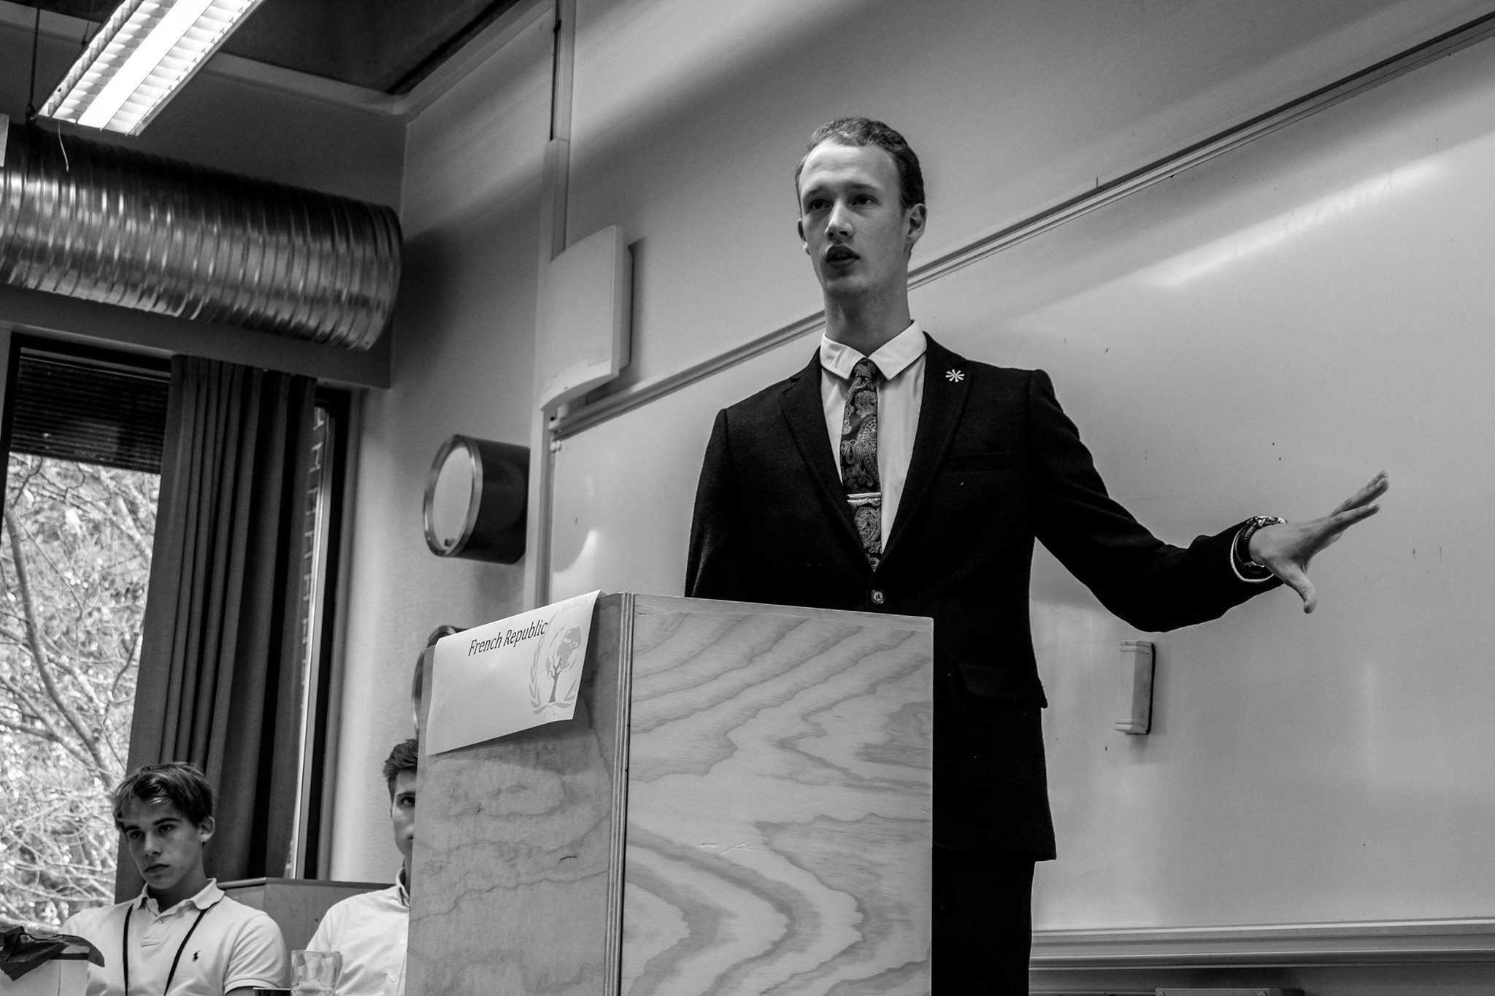
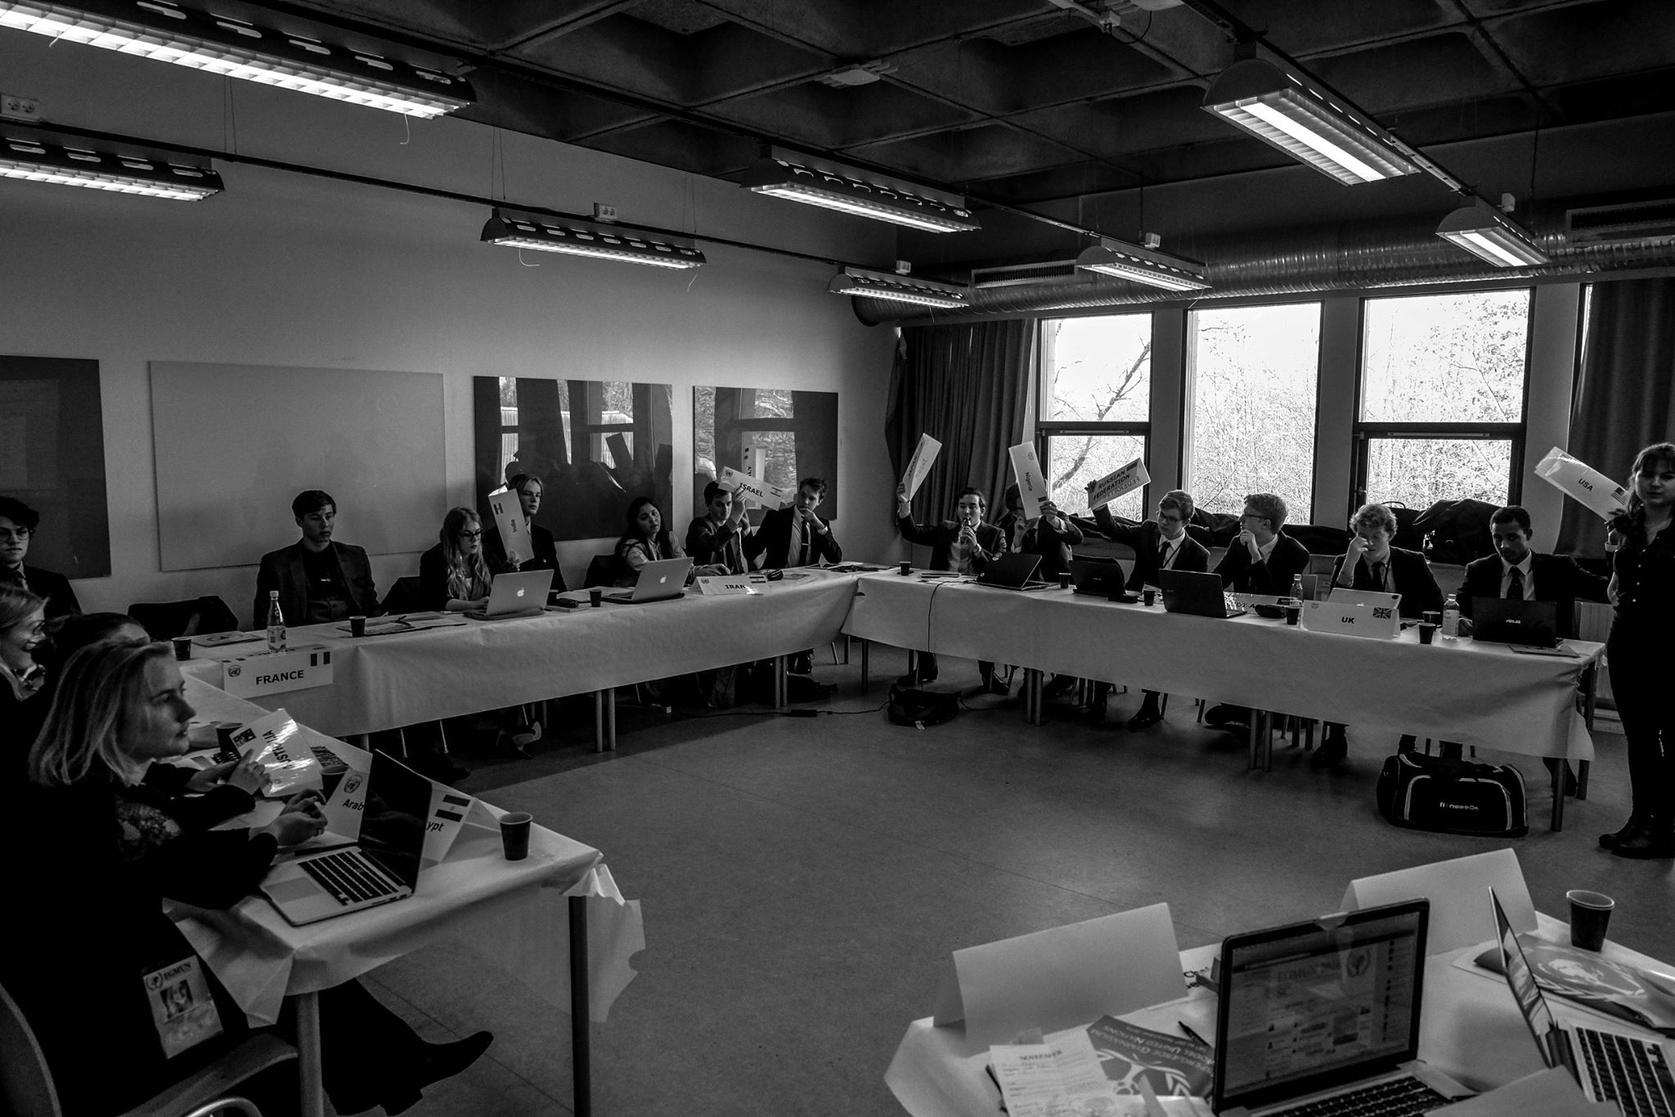
EGMUN 2018 AGENDA – SPECIAL FORUMS

9

United Nations Environmental Programme (UNEP)
- The question of ensuring further development of sustainable energy sources in UN member nations
- The question of reducing pollution in coastal regions and the global marine environment
- The question of preserving the Amazon rainforest

Security Council (SC)
- Measures to reach peace and stability in Somalia
- Preventing and combating the spread of terrorism in the middle east
- The question of establishing peace and stability in Myanmar

Crisis Committee (CC)
- /CLASSIFIED/

Historic Security Council (HSC)
The Historic Security Council of EGMUN 2018 will be placed in the years 1950 and 1955, delegates must act, debate, and indeed research their countries’ policies in the giving years
- 1 November 1955, The question of stabilizing the conflict between Vietnam and the United States of America
- 25 june 1950, Ensuring the dispatch of UN forces to Korea

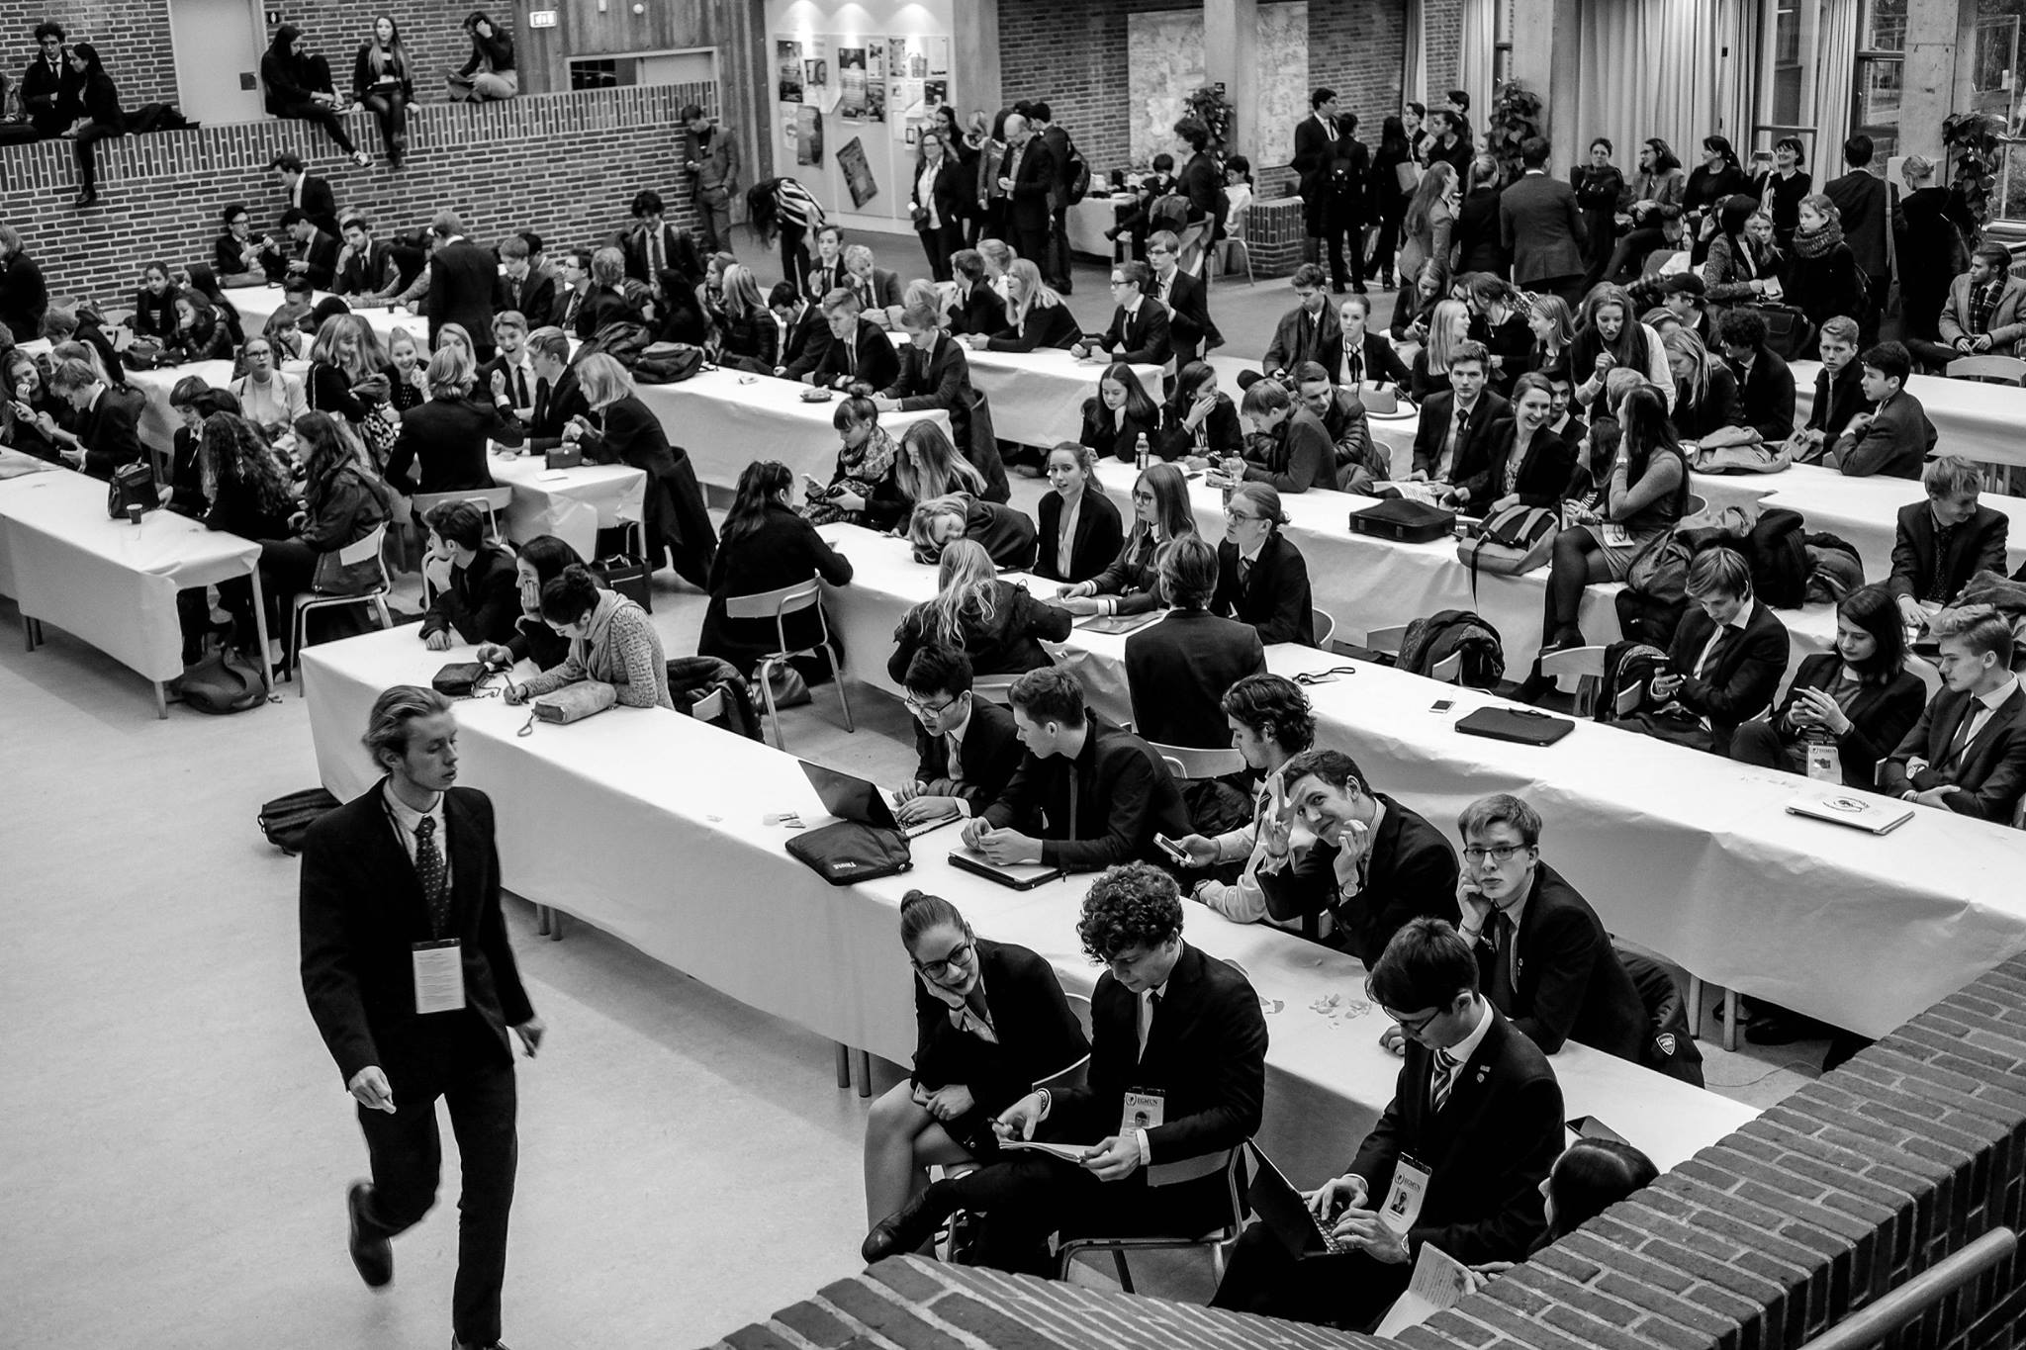
Espergærde Gymnasium Model United Nations 2018. Session XVI
DELEGATE INFORMATION
Approval Panel
The Approval Panel is located in the common area on the first floor. In order to get your resolution approved, you will have to submit the resolution to your Chairs and then the Approval Panel. Be aware of the fact, that a resolution most likely won’t be approved at the first or second hand-in. Please bring your own USB for the Approval Panel.

Punishments
During the conference, the Chair or President has the opportunity to punish the delegates or administrative staff. Reasons for punishments can be inappropriate clothing, use of cellphones in session, not acting according to the rules in general, etc. The Chair or President has the final say on a suitable punishment.

Notepaper
Notepaper will be handed out in each forum – please restrict your use to what is highly necessary in order not to disturb the debate. The staff will read all notepapers and if not considered relevant for the debate, they will be handed in to the Chair who will decide upon a suitable punishment. Furthermore, notepapers can be sent to the press to be further examined.

Badges
Every participant will be given a badge, which will be the ticket to the party. It is important not to lose your badge. However, if this should occur, please contact the Secretariat.

Ambassadors
An Ambassador from each member state will be held responsible for the acts of delegates representing the member state.

Dress code
All participants are expected to dress formally i.e. men wearing suits and tie, women wearing a formal dress, suit or other appropriate clothes. Mini-skirts and low cut shirts/blouses will not be allowed. All Chairs have the right to deny incorrectly dressed delegates access to the conference and punish the person in question properly.

11
Smoking and alcohol
In Denmark it is illegal to smoke on the premises of a public building. Therefore, there are strict rules concerning cigarettes in the school area. You are only allowed to smoke outside the school area during the conference. This is also the case during the party at the school!
All students over 18 are allowed to drink alcohol during the parties – but in a limited amount (drink responsibly).

Photocopying and printing facilities
It is possible to connect to the wireless network at the school, and we therefore recommend you to bring your laptop in session. It is ultimately up to the Chair to decide when and how much you can use the laptop. There will also be printers available during the conference and you can contact the IT-staff if there should be any problems with printing.
Please bring your own USB to print.

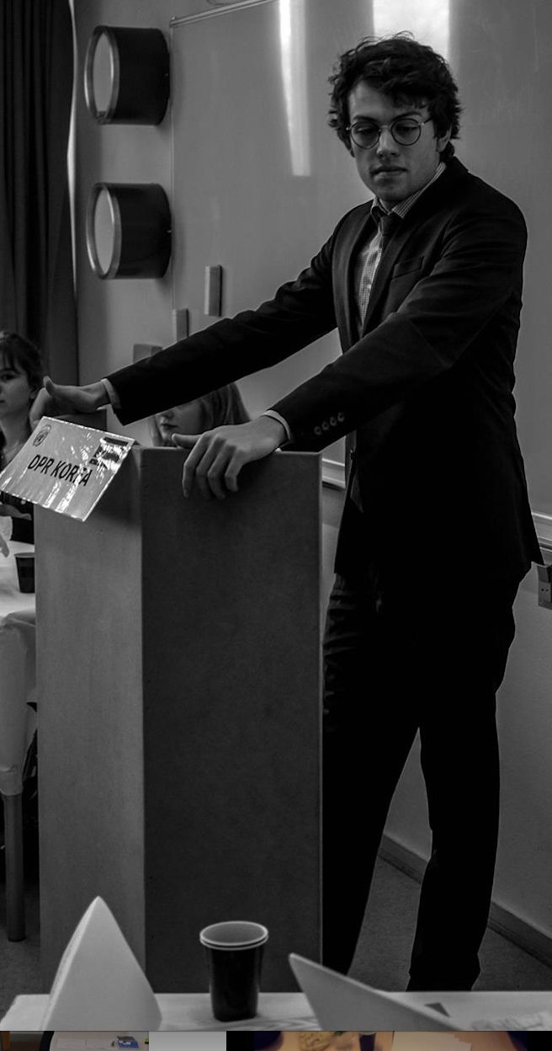
Espergærde Gymnasium Model United Nations 2018. Session XVI
Accommodation
Every foreign participant of EGMUN is either accommodated through private housing or a hostel. If there are any problems concerning accommodation please contact the Accommodation Manager Emmamaia T. Jacobsen on emmamaia@live.dk.

Secretariat
The Secretariat is located on the 1st floor balcony and works as the office of both the Secretary General and the Conference Managers. It will also work as an information desk. If you have any problems, questions etc., feel free to stop by and we will help you.

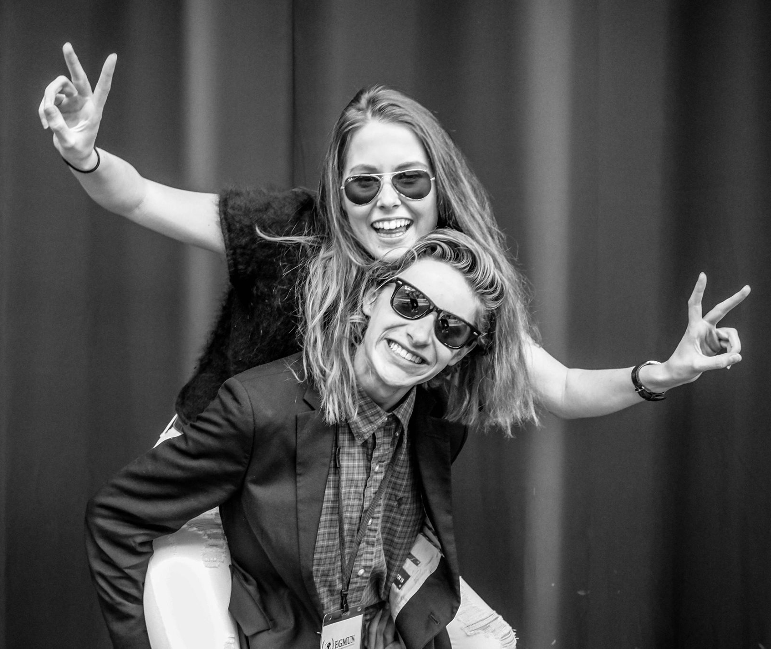
Party
There will be one official party during EGMUN 2018.
The grand official EGMUN party will take place at Espergærde Gymnasium & HF on Saturday the 18th of November. You WILL NOT be able attend without your badge since it works like an ID. There will be served light alcoholic and non-alcoholic drinks.

Meals
From Thursday to Sunday lunch will served in the cantina - also called Bjarne’s. You will have to show your personal badge to receive your lunch. In addition to this, tea, coffee and cookies will be available in the forums during the conference.

Transportation – the local train systems
There are two train systems connecting directly to the school.
Lille Nord - the yellow train that departs from Mørdrup Station and goes to either Helsingør/Elsinore or Hillerød.
Kystbanen - departs from Espergærde Station and will take you either to Helsingør/Elisnore or Copenhagen.
Tickets can be bought at either Espergærde Station or through the DSB-app, called “DOT Mobilbilletter” (which can be set to English). Both sorts of tickets can be used in both train systems as well as in the local busses.
In need of other travel plans than the ones provided above, you can use the website “journeyplanner.dk” to find you way to your destination.

The property of EG
Staying at Espergærde Gymnasium & HF you have to – at all times – respect the school and properties belonging to the school. If anything is destroyed during EGMUN it is the Executive Staff who has the responsibility, but you will also be held personally responsible. Please be respectful of the school and EG-MUN.

130
Emergencies
The local police: +45 49 27 14 48
The emergency service phone number: 112
The urgent health issues phone number: 1813
The emergency police phone number: 114

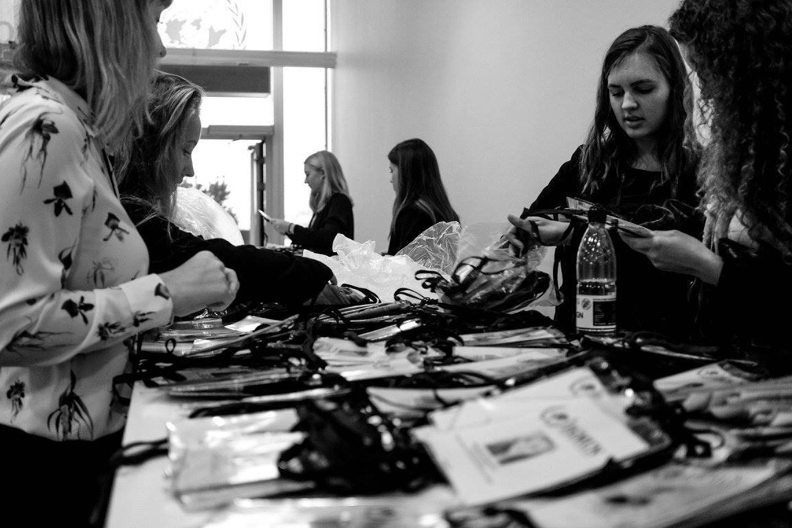
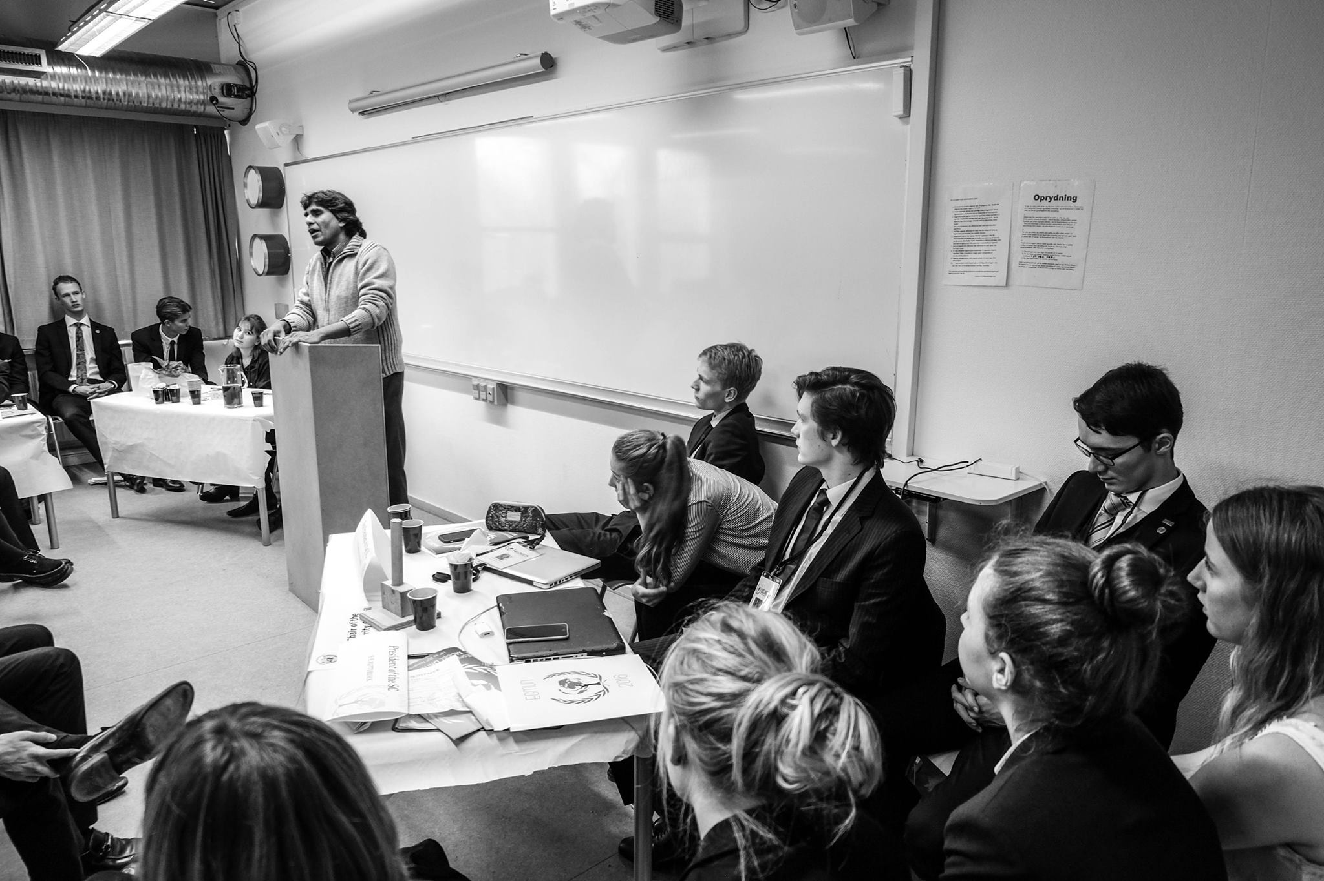
Espergærde Gymnasium Model United Nations 2018. Session XVI
EGMUN Directors
Rolf Mortensen rm@eg-gym.dk +45 28 30 82 95
Thomas Rasmussen hr@eg-gym.dk +45 41 41 03 88
Please note that EGMUN is a conference arranged by students for students - questions concerning the conference will most likely be best answered in the Secretariat on the 1st floor.

EGMUN Directors
A complete overview of the rules of procedure can be found at our website: www.egmun.org
Note that the rules of procedure for the Crisis Committee (CC), the Historic Security Council (HSC) and Security Council (SC) differ from the rules of procedure for the committees of the GA and the commissions of the ECOSOC.

DIRECTIONS

In this section you will find directions for finding the train stations near the school, getting to and from the hostels and getting home at night.

Espergærde Gymnasium to Espergærde Train Station

Walk from the school via Gymnasievej to Hovvej.
Walk straight forward via Rugmarken.
When you reach Nørremarken, turn right, and then follow Nørremarken to the traffic lights.
You have reached Espergærde St.

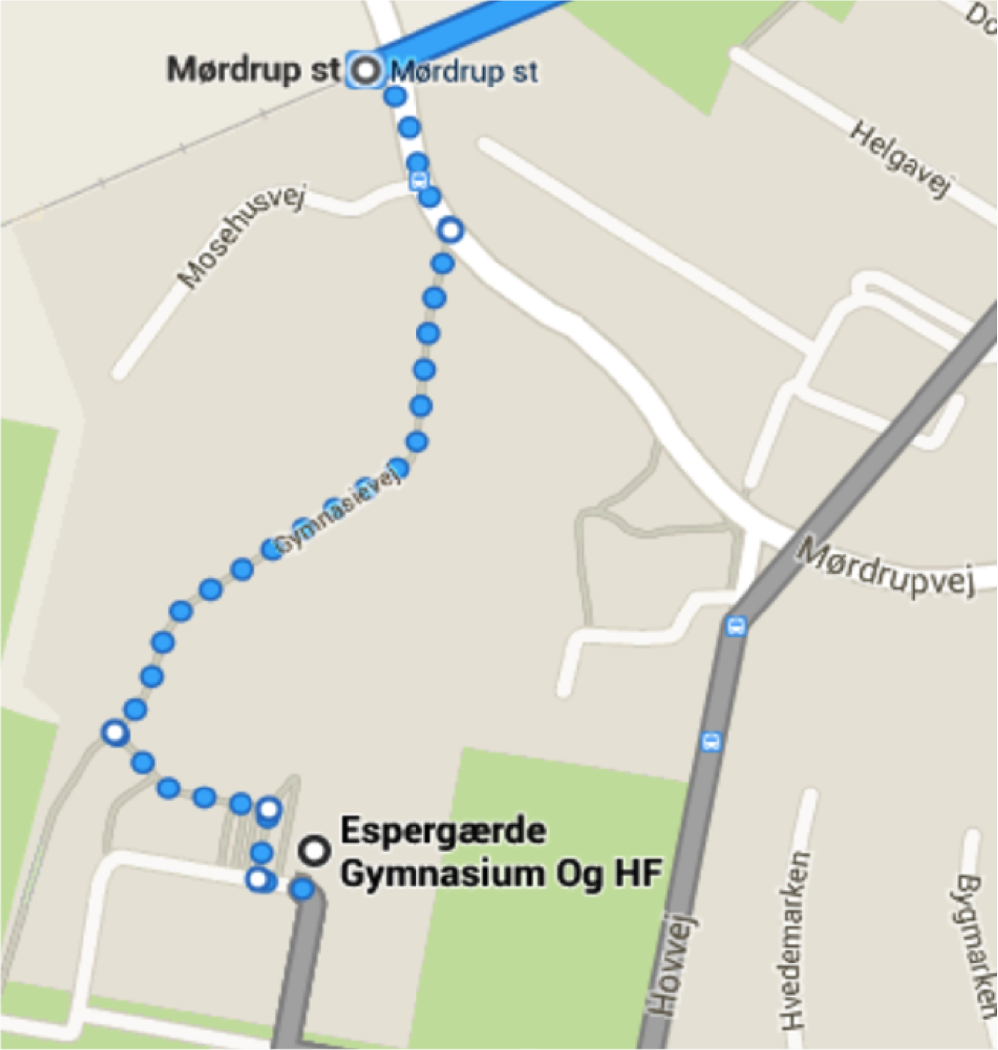
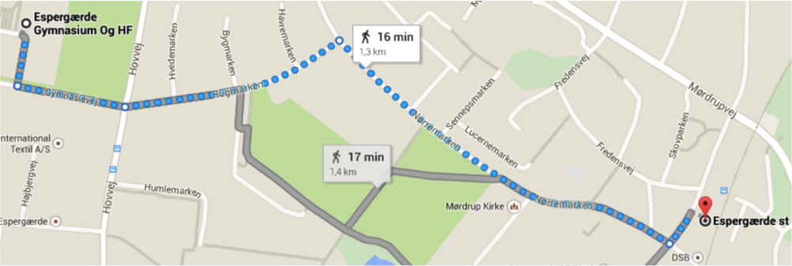

Espergærde Gymnasium to “Mørdrup” Train Station in Espergærde

Mørdrup station is right next to the school. This is the station you will need to use if you’re going to Fredensborg (the train is continuing on to Hillerød) or Elsinore (Helsingør).

Just follow the map to the right
Elsinore Train Station to DanHostel Helsingør

15

Walk from Stationspladsen, and continue onto Havnepladsen.
Continue to Brostræde.
Turn right onto Stengade.
Turn left onto Sct Anna Gade.
Slight right onto Sct Anna Gade/Route 237.
Turn right onto Nordre Strandvej.
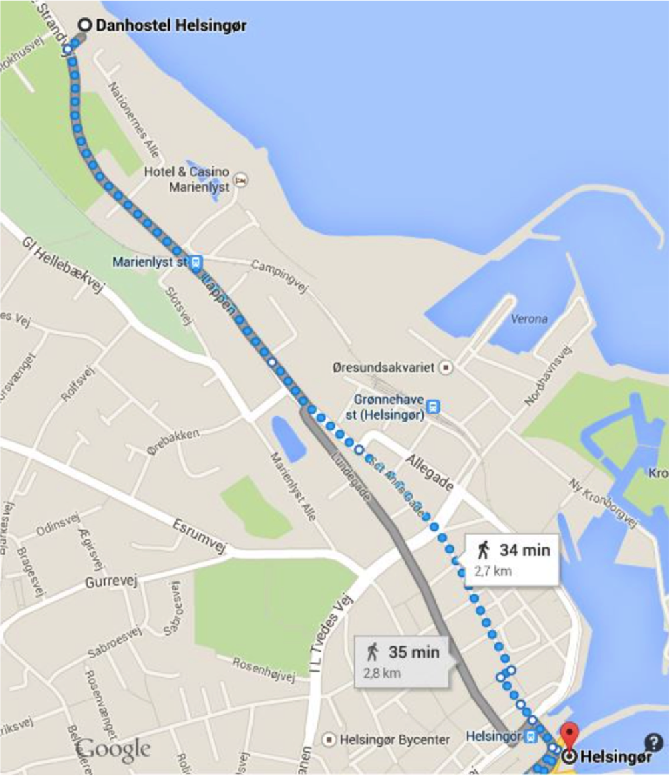
You ́ve reached Danhostel Helsingør.
Espergærde Gymnasium Model United Nations 2018. Session XVI
Fredensborg Train Station to DanHostel Fredensborg

Head southwest on Stationsvej toward Benediktevej.
Turn right onto Jernbanegade.
Continue straight to stay on Jernbanegade.
Slight left to stay on Jernbanegade
Turn left onto Slotsgade.
Turn right onto Østrupvej.
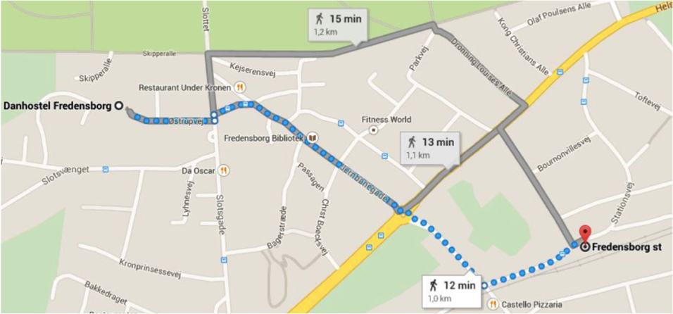

Contact information for the two hostels

Danhostel Fredensborg
Østrupvej 3,
DK-3480 Fredensborg, Denmark
Phone: +45 48 48 03 15

Danhostel Helsingør/Elsingore
Nordre Strandvej 24,
DK-3000 Helsingør/Elsingore, Denmark
Phone: +45 49 28 49 49

PARTICIPATING SCHOOLS

17
School | Country | Representing
Balerno High School | Scotland | French Republic
Birkerød Gymnasium, HF, IB and Boarding School | Denmark | Federative Republic of Brazil & United Kingdom of Great Britain and Northern Ireland
Copenhagen International School | Denmark | Greece & Islamic Republic of Pakistan
Espergærde Gymnasium & HF | Denmark | Canada, Commonwealth of Australia, Democratic People's Republic of Korea, Egypt, Federal Republic of Somalia, Islamic Republic of Iran, Islamic Republic of Afghanistan, Kingdom of Saudi Arabia, Kingdom of Sweden, Kingdom of the Netherlands, Mexico, Nigeria, People's Republic of Bangladesh, People's Republic of China, Poland, Republic of Estonia, Republic of Finland, Republic of Guatemala, Republic of India, Republic of Indonesia, Republic of Iraq, Republic of Korea, Republic of Zimbabwe, South Africa, State of Israel, Syrian Arab Republic, United States of America & Yugoslavia
Escola Pia Nostra Senyora | Spain | Federative Republic of Brazil, Hungary & Ukraine
Helsingør Gymnasium | Denmark | Japan, Kingdom of Spain, Portuguese Republic, Republic of Austria
Lyngby Gymnasium | Denmark | republic of Ireland
Malmö Borgarskola | Sweden | United States of America
Nørre Gymnasium and IB Department | Denmark | Commonwealth of Australia & Republic of Colombia
RIMUN group | Italy | Federal Republic of Germany & French Republic
Rysensteen Gymnasium | Denmark | Belarus, Italy & Kingdom of Norway
Tallinn German Gymnasium | Estonia | Russian Federation

Espergærde Gymnasium Model United Nations 2018. Session XVI

AND THOSE TO WHOM WE EXPRESS UR EXCEPTIONAL GRATITUDE…

- Hermod Lannungs Fonden

- SparNord Fonden

- Henrik Boberg Bæch, Principal of Espergærde Gymnasium & HF

- The most helpful secretaries at Espergærde Gymnasium & HF: Tina Klintenberg, Trine Anker Hansen, Jannie Thorsen, Connie Zeymer Jørgensen and Dorte Jonassen

- MUN-Directors Rolf Mortensen and Thomas Rasmussen

- Opening Ceremony Guest Speaker Mikkel Vedby Rasmussen

- Henrik Arbo-Bähr

- Bjarne and Lily - The Cantina

- All host families

- Danhostel Fredensborg

- Danhostel Helsingør

- All members of the Executive Staff

Rules of Procedure

19

Language

The official- and working language of the conference shall be English at all times.

Dress Code

Male delegates are to be suitably dressed, wearing long trousers, jacket, shirt, tie, and suitable shoes.
Female delegates are to wear a trouser-suit or coat and skirt. Skirts should not end higher than one palm over the knees and shirts must have an appropriate neckline.
Non-compliance with the dress code may lead to a reprehension and is to be corrected for the further proceedings of the conference.

Notepapers

The passing of notepapers is a possibility for the delegates to communicate within their forum solely on agenda-related issues.
Notepapers will only be written in English, the formal language of EGMUN.

By raising a hand a delegate signals to be in need of a notepaper and will be provided by the Staff.

The notepaper will be screened by the Staff. If not in order it is handed over to the President for further consideration.

Any delegate may contact his ambassador by using a notepaper.

The President may at any point of time suspend notepaper passing.
Espergærde Gymnasium Model United Nations 2018. Session XVI

Notepaper passing is suspended during voting procedures.

Points and motions

The difference between points and motions is that points concern a delegate or a chair alone, and a motion concern the entire committee. Therefore, a motion always requires an /informal) vote, usually done by asking if there are any objections. Points or motions may never interrupt a speaker, expect for a point of personal privilege due to audibility. DO note that the chair may overrule all points and motions.

Points

Point of Personal Privilege
This point can be used to refer to anything concerning a delegate’s comfort and wellbeing. This is also the only point that can interrupt a speaker, if, and only if, it refers to the audibility of the speaker

Point of Order
Refers to procedural matters only, such as the chair making an error in the order of debate. It can only refer to something that has just happened, but may never interrupts a speaker

Example: it is in order for the delegate to speak against this amendment, as we are still in time in favor?

Point of Information to the speaker
A question directed to the delegate having the floor at that time, if the delegate having the floor is willing to answer points of information. You may not shout out this point and will have to wait for the chair to ask if there are any points of information in the house, which is when you can raise your placard to possibly get recognized.

If you wish to pose another question directly related to the answer a delegate has given you, you may, after the answer has been given, request a follow-up, as these are allowed at EGMUN. Do note that granting a follow-up is at the discretion of the chair.

Point of information to the Chair
A question to the chair, referring to anything the other points do not cover.
Example: Could the chair please tell us when we adjourn for lunch?

Point of Information to the Expert Chair
A point requesting the clarification on a factual issue referring to the topic currently being departed.

Point of Parliamentary Inquiry
A question regarding the Rules of Procedure, directed to the chair.

Motions

21
All motions require a second a can be objected against. If the latter happens, the chair can decide to take a quick vote of which abstentions are not in order. The motion then needs a simple majority (more votes in favor than against) to pass.

Motion to move to the previous question
Calls for the closure of debate, having a vote on the matter at hand and moving on to the next matter.

Motion to extend debate time
Calls for the extension of debate time on a resolution or amendment.

Motion to table and amendment / a resolution
Calls for debate to end on an amendment or a resolution, without a vote and continue the debate in a later stadium of the conference. This is often done when more time is needed to wright an amendment or to lobby, or when the committee feels it is not appropriate to debate the resolution or amendment at the present time.

Motion to reconsider an amendment / a resolution
This motion calls to continue debate on a previous resolution that has been tabled or has failed in the past debate of the committee. In this case, a 2/3 majority is needed for the motion to pass.
Espergærde Gymnasium Model United Nations 2018. Session XVI

Overview of points and motions

Point/Motion | May interrupt the speaker | Second needed | Speakers | Vote (only after an objection) | Description
Point of personal privilege due to audibility | Yes | No | None | No | To notify the chair that you cannot hear the speaker
Point of personal privilege | No | No | None | No | To notify the chair that you experience discomfort (for example: when a window should be opened)
Point of order | No | No | None | No | To notify the chair that an error has been made regarding the Rules of Procedure
Point of parliamentary inquiry | No | No | None | No | To ask the chair a question about the Rules of Procedure
Point of information to the chair | No | No | None | No | To ask the chair a question about something not concerning the Rules of Procedure (for example: the times of lunch).
Motion to move to the previous question | No | Yes | 2 against | Simple majority | To close the debate on the current amendment/resolution.
Motion to extend debate time | No | Yes | 1 in favour, 1 against | Simple majority | To extend debate time on the current amendment/resolution.
Motion to divide the house | No | Yes | None | Simple majority | To propose a roll call vote. Only possible when there is a minor difference between votes.
Motion to table the resolution | No | Yes | 1 in favour, 1 against | 2/3 majority | To adjourn debate on the current resolution. After all other resolutions have been discussed, debate will continue.
Motion to reconsider a resolution | No | Yes | 1 in favour, 1 against | 2/3 majority | Calls to continue debate on a previous resolution that has been tabled or has failed in the past debate of the committee.

FORUM: Special Conference on Sustainable Urbanization Sub-commission 1

23
QUESTION OF: The Question of Food Security and Sustainable Urbanization
SUBMITTED BY: China
CO-SUBMITTED BY: List Co-Submitters in Alphabetical Order

THE. SPECIAL CONFERENCE ON SUSTAINEBLE DEVELOPMENT,
Defining sustainable development “Development that meets the needs of the present without compromising the ability of future generations to meet their own needs”, following the World Commission on Environment and Development’s (the Brundtland Commission) report ‘Our Common Future’,

Bearing in mind that sustainable a development is generally known to the consist of several sub-topics, namely ecology, economy and equity, and sometimes also institutions or governance,

Considering that in order to achieve food security, the 4 pillars of food security: access, availability, quality referring to the safety of the food, and stability referring to the price stability of food in terms of income security,

- Expresses its hope for the Food and Agricultural Organization (FAO) to help people wanting to start farms by:
- providing the necessary tools and knowledge to start a farm
- giving loans to people to buy the land on which to have their farm
- giving equal opportunities for all genders to start their own farms;

- Recommends the construction of greenhouses to increase the quality and quantity of food in countries with difficult climates for agricultural production;

- Promotes the subsidizing of private agricultural enterprises who share their knowledge in area of agricultural innovation, by means such as but not limited to:
- spreading more sustainable methods of farming, such as the methods of:
- crop rotation
- cover crops
- the improvement of infertile land
- the safety of agricultural workers educating workers, educating them to:
Espergærde Gymnasium Model United Nations 2018. Session XVI
- exercise caution at all times
- properly take care of and handle equipment
- wear protected clothing and equipment.

Every clause in your resolution should start with one of the phrases stated below.
There are separate phrases for pre-ambulatory clauses and operative clauses. There are some phrases only the delegates of the Security Council is allowed to use (of course they can also use the other phrases); these phrases are stated in bold.

Please note that the Approval Panel is often busy, especially on Saturday morning. To speed up the approving process, we greatly encourage you to send your resolution on Friday afternoon / evening, to have it ready for debate on Saturday morning. Also, we encourage you to make sure your grammar and your phrasing are correct, as well as the layout of your resolution.

Pre-ambulatory phrases
Guided by
Having adopted
Having considered
Having considered further
Having devoted attention
Having examined
Having heard
Having received
Having studied
Keeping in mind
Noting with regret
Noting with deep concern
Noting with satisfaction
Noting further
Noting with approval
Observing
Reaffirming
Realizing
Recalling
Recognizing
Referring
Seeking
Taking into account
Taking into consideration
Taking note
Viewing with appreciation
Welcoming

Acknowledging
Affirming
Alarmed by
Approving
Aware of
Bearing in mind
Believing
Confident
Contemplating
Convinced
Declaring
Deploring
Deeply concerned
Deeply conscious
Deeply convinced
Deeply disturbed
Deeply regretting
Desiring
Emphasizing
Expecting
Expressing its appreciation
Expressing its satisfaction
Fulfilling
Fully alarmed
Fully aware
Fully believing
Further recalling
Further declaring

Operative phrases

25
Further invites
Further proclaims
Further reminds
Further recommends
Further requests
Further resolves
Has resolved
Notes
Proclaims
Reaffirms
Recommends
Regrets
Reminds
Requests
Solemnly affirms
Strongly condemns
Supports
Takes notes of
Transmits
Trusts
Urges

Accepts
Affirms
Approves
Asks
Authorizes
Calls
Calls upon
Condemns
Confirms
Congratulates
Considers
Declares accordingly
Demands
Deplores
Designates
Draws the attention
Emphasizes
Encourages
Endorses
Expresses its appreciation
Expresses its hope
Espergærde Gymnasium Model United Nations 2018. Session XVI

