EGMUN 2018
United Nations Development Programme (UNDP)
Research Report

Topic 3: Securing ocean life by seeking to have countries limit their pollution and stop overfishing the seas.

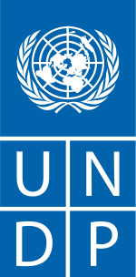

Rebin Nerway Rashid

Table of contents
1.Introduction 3
2. Issues related to it today. 3
2.1 Overfishing 3
2.2 Pollution 3
3. Most affected countries 4
4. Possible solutions 5
5.Bibliography………………………………………………………………………………………… 5

1. Introduction:
Goal 14 of the United Nations’ development program aims to conserve and sustainably use the oceans and seas for sustainable development. Oceans cover three-quarters of the Earth’s surface and are the habitat for numerous species. Pollution and overfishing are massive problems that disrupt and affect ocean life. Today 40 percent of the ocean around the world is heavily affected by pollution, depleted fisheries, and other human activities.

2. Issues related to it today:
2.1 Overfishing:
Overfishing is a problem that has serious consequences for the world. It occurs when the amount of fish caught in the water is so huge that the population cannot replace them through natural reproduction. Not only does it have an impact on life in the oceans, but more than a billion people in the world rely on fish for protein.
Fishing is an essential part of the economy in the world. Overfishing gives an economic loss due to it threatening coastal nations down to the local level.

Poor fisheries management and illegal fishing are some of the main causes of overfishing in the world. In high seas, there are few international fishing regulations, and those that exist are not always implemented or enforced. It is not always that the customs agencies and retailers can ensure that the fish entering their country is caught legally and in a sustainable way.
In the national and international waters, there is a crisis regarding unregulated and unreported fishing. 20% of the world’s catch accounts for illegal fishing while accounting for 50% in some fisheries.

2.2 Pollution:
Statistics show that more than 8 million tons of plastic leak into the ocean every year. The ocean today absorbs around a quarter of all man-made carbon emissions. This means that certain things such as fossil fuel not only pollute the air, but also the ocean. The oceans are now acidifying the fastest in over 300 million years. If the chemistry of the ocean was to go out, it would result in the Marine ecosystems and the coastal economies to also go out of whack.

Trash in the oceans is a major factor for pollution on the planet. The plastic in the seas and oceans will not biodegrade. It can persist in an environment for a thousand years and is likely to get ingested by fish and seabirds. According to Ocean Conservancy, there will be more plastic than fish in the oceans by 2050 with the amount of plastic expected to grow up to 250 million tons by 2025.

3. Most affected countries:
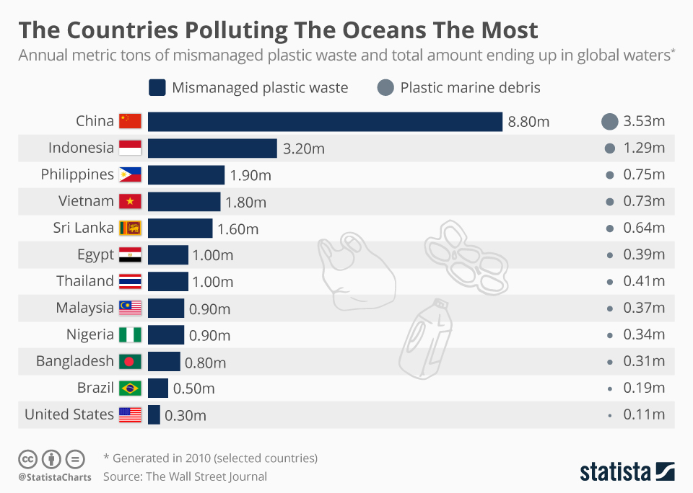August 7th 2018
China, the country with over 1.3 billion people in their population, is also the country that pollutes the oceans the most. Indonesia’s Citarum River is the most polluted river in the world. In March 2018, the government of Indonesia had to send the army in to help clear the pollution of the area. The statistic shows that the majority of the polluted oceans is coming from Asian countries. On average only 40% of the garbage ends up properly collected in the five most polluted countries.

According to the FAO, the world’s commercial fish stocks that exist at biologically sustainable levels has declined from 90% to 68% between 1974 and 2013.
China was in 2014 accounted for over 18% of the global marine catch according to FAO and is projected to account for 38%, which is more than double the amount that the rest of the world accounts for. Ireland ranks as the worst overfishing country in the Atlantic after exceeding their total allowed catch by 17.8 percent.

4. Possible solutions:
4.a Sustainable fishing
By 2020, effectively regulate harvesting and end overfishing, illegal, unreported and unregulated fishing and destructive fishing practices and implement science-based management plans, in order to restore fish stocks in the shortest time feasible, at least to levels that can produce maximum sustainable yield as determined by their biological characteristics

4.b End subsidies contributing to overfishing
By 2020, prohibit certain forms of fisheries subsidies which contribute to overcapacity and overfishing, eliminate subsidies that contribute to illegal, unreported and unregulated fishing and refrain from introducing new such subsidies, recognizing that appropriate and effective special and differential treatment for developing and least developed countries should be an integral part of the World Trade Organization fisheries subsidies negotiation.
4.c Reduce marine pollution
By 2025, prevent and significantly reduce marine pollution of all kinds, in particular from land-based activities, including marine debris and nutrient pollution.

5. Bibliography:

https://www.nationalgeographic.com/environment/oceans/critical-issues-overfishing/

https://www.un.org/sustainabledevelopment/oceans/

http://www.undp.org/content/undp/en/home/sustainable-development-goals/goal-14-life-below-water.html

https://www.worldwildlife.org/threats/overfishing

http://web.unep.org/unepmap/un-declares-war-ocean-plastic

https://www.nrdc.org/stories/ocean-pollution-dirty-facts

https://www.statista.com/chart/12211/the-countries-polluting-the-oceans-the-most/

