Introduction
The intention of this research is to shed a light on the topic of preventing and combating the spread of terrorism in the Middle East. However, it should in no way be perceived as conclusive, and it is therefore encouraged that the delegates extend their scope of knowledge beyond this paper. As terrorism, both in terms of scope and complexity continues to expand, the need for international cooperation is becoming increasingly relevant. This has led to the establishment of The United Nations Office of Counter-terrorism (15 June 2017).
Statement of the Issue
Preventing and combating the spread of terrorism in the Middle East.
Background and History
The topic of terrorism has always been a thing of great concern for the UN and its member nations. Terrorism has spread all over the world and has taken many innocent lives and brought suffering to multitudes of peoples. Although there has not been made a definitive definition, the UN has come up with various definitions, such as; “criminal acts, including against civilians, committed with the intent to cause death or serious bodily injury, or taking of hostages, with the purpose to provoke a state of terror in the general public or in a group of persons or particular persons, intimidate a population or compel a government or an international organization to do or to abstain from doing any act, which constitute offences within the scope of and as defined in the international conventions and protocols relating to terrorism, are under no circumstances justifiable by considerations of a political, philosophical, ideological, racial, ethnic, religious or other similar nature.” As previously mentioned, terrorism has caused havoc all over the world, be that as it may, the Middle East has had the unfortunate burden of having harboured the majority of these. The number of terrorist attacks worldwide, especially in the Middle East, have skyrocketed over the past decade, which is demonstrated in the following figure:
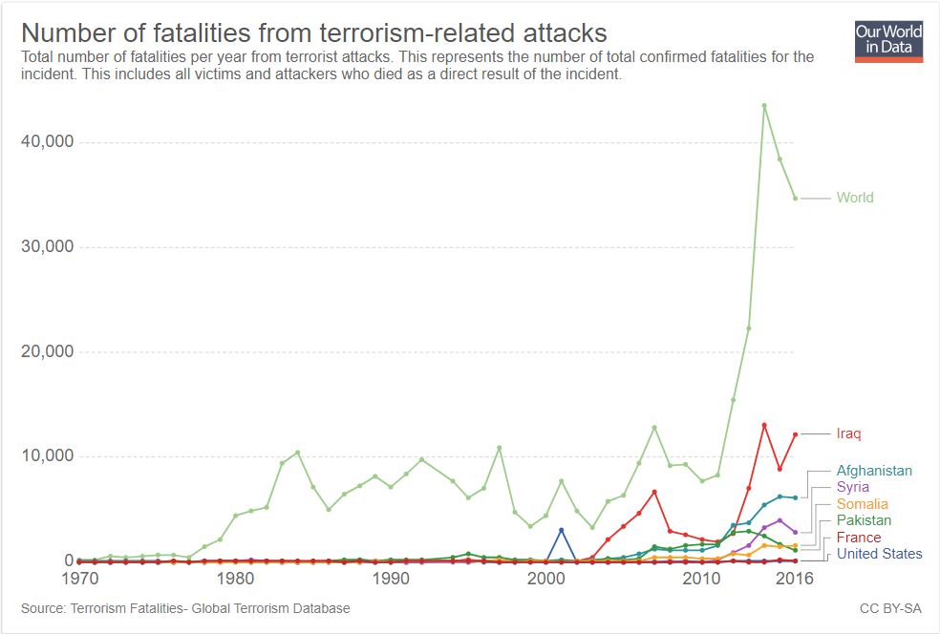
-Figure 1, https://ourworldindata.org/terrorism

Tuesday 11th September 2001 became a turning point in world history and the beginning of “the War on Terror”, on that day the world witnessed one of the most devastating terror attacks it had ever seen, and The United States of America became the victim of this great tragedy. The attack has later become known as 9/11. This day has been embodied as a day of sorrow and one of the most prominent examples of modern terrorism. The attacks became a catalysator for terrorism. The attack may have targeted The United States of America however it has been the incentive of many more of these acts of violence, whereas many have been carried out in the Middle East. The following table summarises the concentration of terrorist attacks pre- and post-9/11. It reveals that terrorism pre-9/11 was concentrated in Latin America and Asia but shifted to the Middle East post-9/11, whereas Peru, Chile, and El Salvador completely disappear from the top 10. More than a quarter of all terrorist attacks between 9/11 and 2008 took place in Iraq. 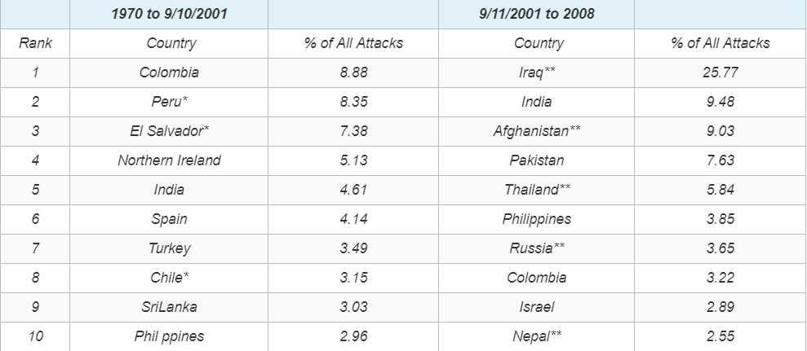
-Figure 2, https://ourworldindata.org/terrorism
After 9/11 the western world, especially The United States of America, were in as state of distress. Thus, The United Nations Global Counter-Terrorism Strategy was adopted by General Assembly resolution 60/288 in 2006, and states that terrorism “constitutes one of the most serious threats to international peace and security”.
Motivation
The motivation behind these attacks is of course different from case to case, however the majority of the attacks can be divided into one of the following categories; political violence or violence in the name of religious beliefs.
Political purposes: For decades the western world has tried to establish democratic governments in most Middle Eastern countries, with a very mixed success rate. Mutual for all these cases are that there has been some sort of resistance in the population. Many groups have protested peacefully, but regretfully that has not been the case for all countries. Instead these groups have turned militant, and the war on terror has been born. A war between militant terror organizations and the western world, and for decades the Middle East has been the battlefield, and millions of innocent citizens have been victims, held as captives in their ancestral lands. War has always been ugly; however, terrorism is no match. Elections and voting in the western world can seem easy and straightforward, but in the Middle East you’re putting your life on the line. Countless people have lost their lives to terrorism in the form of bombings of polling stations, they have lost their lives when they have defied fear and oppression and fought for a brighter future, these people who act in immense braveness must be protected. The anti-democracy terrorist groups deliberately target polling stations to bring fear into the population. Their goal is clear; equate voting with death, to scare democracy away. Many candidates have also lost their lives in the battlefield for a democratic Middle East: At the 2016 parliamentary election in Afghanistan 10 candidates lost their lives during the election. In Pakistan a group of suicide bombers, from ISIS, claimed the life of 149 people voting at a voting station this summer, with a total of 17000 criminal cases from activists during that one election.
Religious purposes: Sadly, many religious groups are willing to act in violence in order to expand their religion, this has been the case for many religions throughout history, in nowadays Middle East, it is most commonly from Islamic groups, ISIS, Hamas, and al-Qaeda being the most prominent ones. Islamic terrorists justify their violent tactics through the interpretation of the Quran and Hadith according to their own goals and intentions. The idea of Islamic supremacy is encapsulated in the formula, "Islam is exalted and nothing is exalted above it." In 2015 four Islamic extremist groups were responsible for 74% of all deaths from terrorism: ISIS, Boko Haram, the Taliban, and Al-Qaeda, according to the Global Terrorism Index 2016. Many of the violent terrorist groups use the name of Jihad to fight against certain Western nations and Israel. An example is bin Laden's al-Qaeda, which is also known as "International Islamic Front for Jihad Against the Jews and Crusaders". Most militant Islamists oppose Israel's politics, and they often oppose its very existence. The historic rivalry between Hindus and Muslims on the Indian subcontinent has also often been the primary motive behind some of the most deadly terrorist attacks in India. According to a U.S. State Department report, India topped the list of countries most affected by Islamic terrorism.
The Muslim world has been afflicted with economic stagnation for many centuries. In 2011, U.S. President Barack Obama stated that apart from crude oil, the exports of the entire Greater Middle East with its 400 million population roughly equals that of Switzerland. It has also been estimated that the exports of Finland, a European country of only five million, exceeded those of the entire 370 million-strong Arab world, excluding oil and natural gas.
After the infamous 9/11 attacks many western countries deployed troops in Iraq and Afghanistan, and as a result more than a million people have died over a timeline shorter than two decades, regretfully many of whom were citizens. The many lost lives and the damage that has been inflicted on the nations, have caused many citizens to turn against the western world, and a mouldering hate has been born. This hate has been manipulated by many groups, and it has been the motive for many terrorist attacks. Sad as it may seem, killings and violence is being answered by more violence and unnecessary deaths.
Relevant international actions:
The EU adopted a comprehensive approach to tackle the issues of foreign fighters and home-grown terrorism. Recent actions in this area include:
- strengthened rules to prevent new forms of terrorism
- reinforced checks at external borders
- enhanced firearms controls
- creating a dedicated body to curb terrorist propaganda online
Gilles de Kerchove has been the EU Counter-Terrorism Coordinator since 2007. He is in charge of:
- coordinating the work of the Council of the EU in the field of counter-terrorism
- monitoring the implementation of the EU counter-terrorism strategy
- ensuring that the EU plays an active role in the fight against terrorism
The United Nations General Assembly adopted the Global Counter-Terrorism Strategy on the 8th of September 2006. The strategy is a unique global instrument to enhance national, regional, and international efforts to counter terrorism. Through its adoption all Member States have agreed, for the first time, to a common strategic and operational approach to fight terrorism. Not only sending a clear message that terrorism is unacceptable in all its forms and manifestations, but also resolving to take practical steps individually and collectively to prevent and combat it. Those practical steps include a wide array of measures ranging from strengthening state capacity to counter terrorist threats to better coordinating United Nations system’s counter-terrorism activities. The General Assembly reviews the strategy every second years, making it a living document attuned to Member States’ counter-terrorism priorities.
The Global Counter-Terrorism Strategy in the form of a resolution and an annexed Plan of Action (A/RES/60/288)composed of 4 pillars
- Addressing the conditions conducive to the spread of terrorism
- Measures to prevent and combat terrorism
- Measures to build states’ capacity to prevent and combat terrorism and to strengthen the role of the United Nations system in that regard;
- Measures to ensure respect for human rights for all and the rule of law as the fundamental basis for the fight against terrorism.
Russian Deputy Prime Minister Valentina Matviyenko announced in October 2002 that the Russian government would provide aid to Afghan refugees leaving Afghanistan if counter-terrorism operations against the Taliban created a humanitarian disaster.
The Global Coalition against Daesh was formed in September 2014 and is unique in its membership, scope, and commitment. Together, the Global Coalition is committed to degrading and ultimately defeating Daesh. The Coalition’s 79 members are committed to tackling Daesh on all fronts, to dismantling its networks and countering its global ambitions. Beyond the military campaign in Iraq and Syria, the Coalition is committed to: tackling Daesh’s financing and economic infrastructure; preventing the flow of foreign terrorist fighters across borders; supporting stabilisation and the restoration of essential public services to areas liberated from Daesh; and countering the group’s propaganda.
France has joined forces with the Global Coalition by launching Operation Chammal to support Iraqi authorities engaged in fighting the terrorist group. In September 2015, faced with the terrorist threat in France, the scope of action of Operation Chammal was extended to include Syria to destroy Daesh’s regional hold in the country. Since 2014, France’s military action has helped to liberate virtually all the regions controlled by the terrorist organization in Iraq and in Syria.

Possible solutions:
The United Nations are yet to effectively deal with terrorism in the Middle East. If terrorism and suffering of the innocent is to come to an end drastic actions are required from the UNSC. Widespread irresponsible arms trade must come to an end. The killings of citizen populations and the oppression against democratic elections can no longer be left unopposed. The widespread belief by the affected populations that all religious groups can live together peacefully must become more prominent. The advantages and disadvantages of methods such as financial aid, ceasefires, taking military action, introducing trade embargos, etc. must be evaluated and implemented accordingly. While it is important for delegates to keep in mind their countries’ perspectives, delegates must also look beyond the immediate interests of their own countries to find mutually beneficial solutions.
Questions to consider:
- What is the UN Security Council capable of doing to address the issue? To what extent should it intervene?
- What can your country do to promote the best possible outcome within the confines of the Security Council proceedings? What is your country’s perspective on the most beneficial outcome?
- What can be done to ensure the privilege of voting and freedom of religion for all Middle Eastern citizens?
- How can the UN Security Council combat the spread of terrorism?

Bibliography:
http://www.un.org/en/sections/where-we-work/middle-east/
http://www.un.org/en/counterterrorism/
https://www.un.org/counterterrorism/ctitf/en/un-global-counter-terrorism-strategy
https://ourworldindata.org/terrorism#rational-motives
https://www.brookings.edu/opinions/put-middle-east-terror-in-global-perspective/
https://www.theguardian.com/world/2018/oct/19/kandahar-election-may-be-suspended-after-police-chiefs-killing
https://www.bbc.com/news/world-asia-44924384
https://www.csis.org/analysis/tracking-trends-and-numbers-islam-terrorism-stability-and-conflict-middle-east
https://www.newyorker.com/news/news-desk/war-terrorism-and-the-christian-exodus-from-the-middle-east
https://www.brookings.edu/blog/markaz/2017/07/28/the-islamic-states-long-term-threat-to-the-middle-east/
https://www.middleeasteye.net/columns/why-terrorism-caused-much-more-just-religion-1344141967
http://theglobalcoalition.org/en/mission-en/
https://en.wikipedia.org/wiki/Islamic_terrorism

